Year One – Labelling parts of a flowering plant
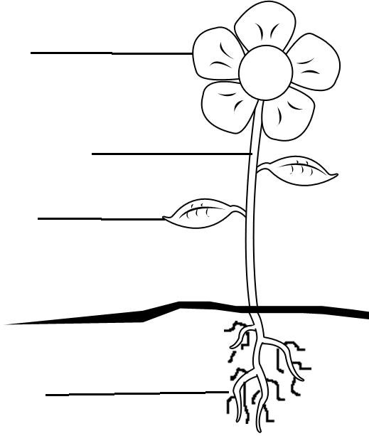

roots stem leaves flower
The makes seed to make a new flower grow.
The are green and make food for the plant.
The is like a straw. It moves water around the plant. It is long and the flower and leaves hang from it.
The take in water and food from the soil. They also help the flower to stand up still.

