SPRING TERM HOME PE

Dice Balance Balance skills
Equipment: Dice or paper with 1-6 written of each. Safe Space
How to play:

Roll the dice or pick a piece of paper and do a balance on the body part that corresponds with the number, see if you can hold the balance for 15 seconds.
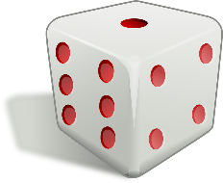
Number 1- Feet
Number 2- Stomach
Number 3- Bottom
Number 4- Knee
Number 5- Back
Number 6- Can you balance with 3 body Parts touching the floor
Challenges:
- Do it again but see if you can hold the balance for 30 seconds.
- Roll the dice three times and see if you can link the 3 balances together to create a little sequence.

Step:

Space- Make the space that you are using to balance on smaller to make it harder.

Task- make a whole sequence using all the balances that you have come up with.

Equipment- Use something that you have in the house or at school, for example a football, to try and balance with.

People- Balance with a partner or group.

SPRING TERM HOME PE

Fitness Circuit Strength, Cardiovascular endurance (fitness)

Equipment: Space and timer
How to play:

Do each activity for 30 seconds with 15 seconds rest, if you can do it three times. You can do these in any order.
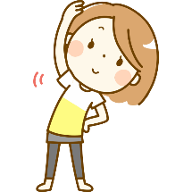
Burpees
Jog on Spot
Star Jumps
Plank
Sit Ups
Press Ups
Lunges
Lay on your back, lift your legs up slightly off the ground and hold
Squats
Heel Flicks

Make sure you have a minute rest before doing it again.
Challenges:
- On the third round do each activity for 45 seconds and only 10 seconds rest.
- Can you make up your own exercises?
Step:

Space- if you have more or outside run between two lines instead of on the spot

Task- Have a longer or shorter break if required

Equipment- add a weight, tin of beans to make the exercise harder.

People- challenge other members of your household.

SPRING TERM HOME PE

Cross the Swamp agility and balance
Equipment: 2 Pillows and 2 towels
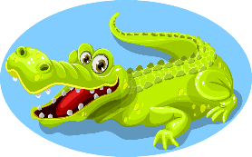
How to play:

Roll up the towel and place each about 10 metres apart, between is the swamp.

Start behind one towel and you need to make your way across the swamp only using the two pillows, if any part on body touches the swamp you must start back at the beginning.

Challenges:
- Time how long it takes you to complete it, challenge someone else.
- If there are more people see if you can do it with two people at the same time.

Step:

Space- Make the swap bigger by moving the towels further apart.

Task- Time yourself and either see if you can beat it the next time round or see if you can beat someone else.

Equipment- Have you got smaller pillows?

People- Try and include your whole family, you may need to add another pillow.

