BALLOON VOLLEYBALL Hand-eye co-ordination
Equipment: a round balloon
How to play:
- Get a parent/carer to blow up a balloon for you (circular ones are easiest for this game, and the more air in, the easier it is for the child as it travels through the air more slowly)
- Try playing inside first (once you have cleared a space and made sure there is nothing that can be knocked over or fell on!)
- Can you keep the balloon off the floor and up in the air?
- Can you use just your hands to control the balloon?
- Now try it outside- but not on a windy or wet day!!

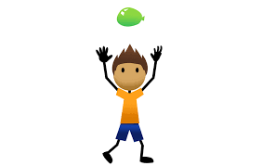

Skill Tip: Keep your eyes on the balloon! Try and only gently push it into the air using your finger tips
Challenges:
- Use other body parts to keep the balloon off the floor- maybe your head or your feet?
- How many touches can you do before the balloon touches the floor?

STEP principle of coaching/teaching- helps to engage, challenge and motivate everyone by altering one or more of the principles
Space - Try and limit the space you are playing in.
Task – Can you use a time limit to add pressure on yourself? How many can you do in 10 seconds?
Equipment – Use a smaller balloon if it is too easy!
People – Once you have mastered playing on your own, try and keep a rally going with a family member

FIND 3 THINGS THAT ARE….. Fitness
Equipment: none
How to play:
- A parent/carer says “find three things that are…….. red”
- The child quickly looks around the room to find three things that are red
- Go through colours, shapes, textured, made of plastic or start with letters of the alphabet
- Extend onto multiple rooms in your house or even the garden

Example of plastic items:
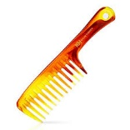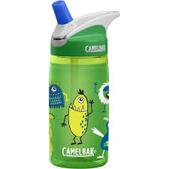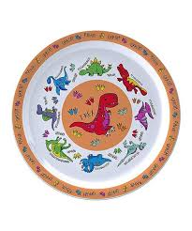
Example of red items:
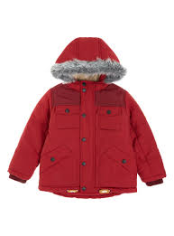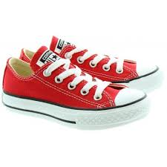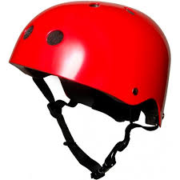
Example of round/circular items:

Skill Tip: Children may need prompting for the items- to start with you may want to get some items visible to get the game going
Challenges:
- Ask the children to come up with the categories and put them into a hat/bowl and pull them out
STEP principle of coaching/teaching- helps to engage, challenge and motivate everyone by altering one or more of the principles
Space - Limit the game to one room to start with and then expand to more rooms
Task – Try combining 2 categories of the object, e.g. red and plastic
Equipment – Suggest once they have brought an item once, they cant bring it again
People – Play against a friend/family member so there is timed pressure

DAILY WALK Fitness
Equipment: wellies, warm clothes, a plastic bag or bucket to collect any ‘treasure’
How to play:
- Remember walk 2 metres apart from anyone not in your household or bubble.
- Be careful when touching opening and closing gates- use your hand gel if you do and wash your hands thoroughly when you get home.
- Have fun on your walk!
1.When you go for a walk see if you can find 3 different types of leaves- can you use the pictures below to identify them?
Oak Ash Chestnut Beech Maple
2. Walk for 10 strides then jog for 10. Can you do this for the whole length of your favourite nursery rhyme?
3. Can you spot any yellow or white flowers?
4. Stop at a lamp post or footpath sign and do 5 start jumps. At the next lamp post hop on the spot for 10 seconds. At the next lamp post skip on the spot for 10 seconds.
5. Gather some twigs and leaves during your walk so that when you get home you can create a new play area for some of your toys or a new bug hotel outside
Challenges:
STEP principle of coaching/teaching- helps to engage, challenge and motivate everyone by altering one or more of the principles
Space - Try and explore a new outside space away from houses and roads
Task – Try and keep a conversation going or singing to keep your heart rate up
Equipment – What interesting objects can you collect during your walk?
People – Get a family member to join in with all the points above- especially points 2 and 4!

Video Further leaf info can be found here: https://nt.global.ssl.fastly.net/documents/woodland-spotter-sheet-frugi.pdf

ALPHABET FITNESS Fitness
Equipment: none
How to play:
- Make sure the room you are in is clear of any objects which might cause an injury or get broken
- Do your first name, e.g. Simon
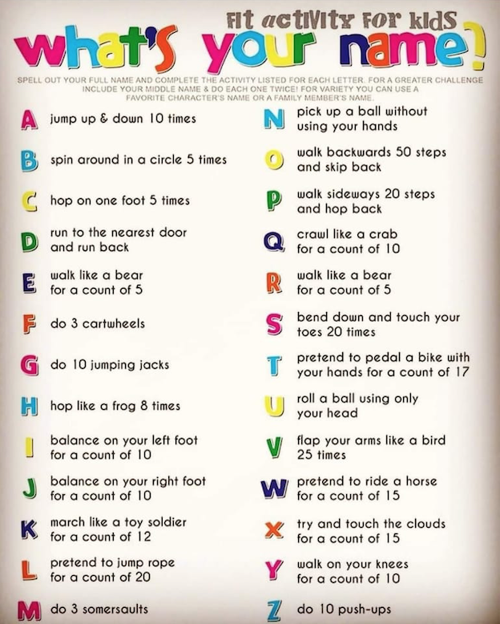
Skill Tip: If you do not like the activity for one of the letters or you cannot do it, then look at the suggestion for the next letter of the alphabet
Challenges:
- Can you do your surname too?
STEP principle of coaching/teaching- helps to engage, challenge and motivate everyone by altering one or more of the principles
Space - Use the length of your lounge or bedroom for when you are moving around
Task – Can you remember the activities and do them again, but better this time?
Equipment – Can you carry your teddy with you throughout the challenge? Don’t drop it!!
People – can you challenge a family member to do their name?

YOGA (From Twinkl) Fitness
Equipment: none
How to play:
Make sure you have cleared the room of any objects which might cause an injury or get broken

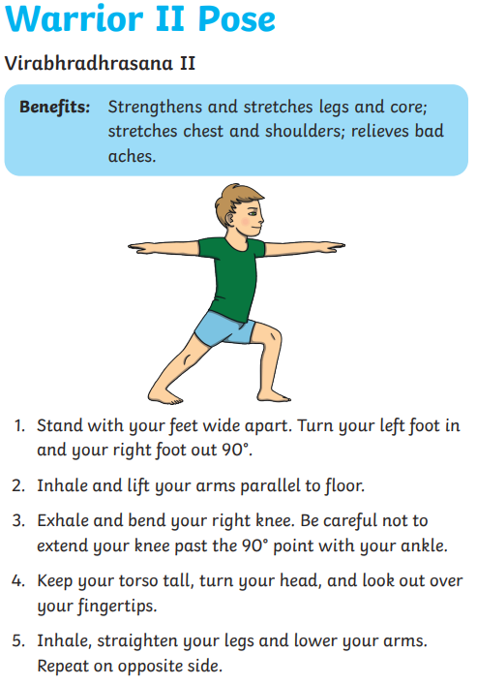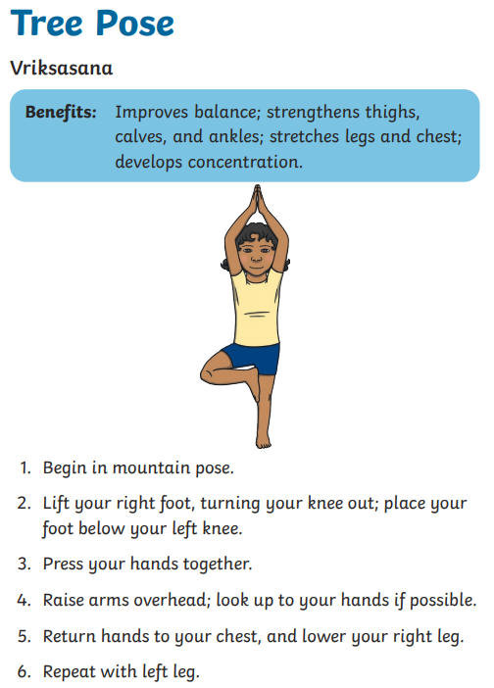

Skill Tip: Remember to keep breathing throughout- don’t hold your breath!
Focus on something in front of you to help with your balance!
Challenges:
- Can you perform the move in front of a mirror or see your reflection in a glass door to check your arms and legs are nice and straight?
- Can you do it better on one foot than the other?
STEP principle of coaching/teaching- helps to engage, challenge and motivate everyone by altering one or more of the principles
Space - You will need to use the space and give yourself something to concentrate on
Task – Can you remember the activities and do them again, but better this time?
Equipment – Can you carry your teddy with you throughout the challenge? Don’t drop it!!
People – can you challenge a family member to perform each move at the same time as you?

PEPPA SAYS……..(From Twinkl) Fitness
Equipment: none
How to play:
The traditional “Simon says” game but using the loveable Peppa Pig characters!
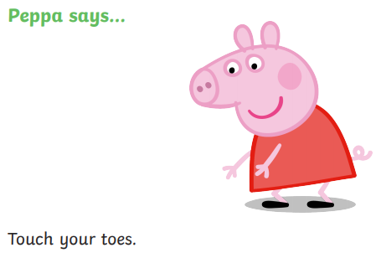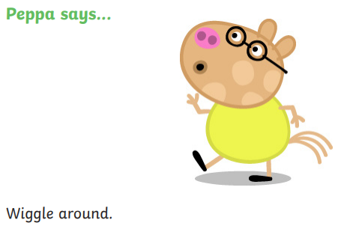

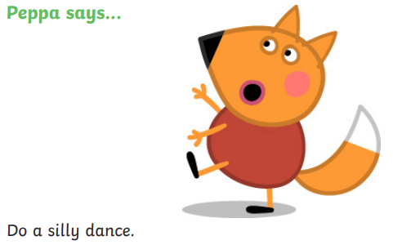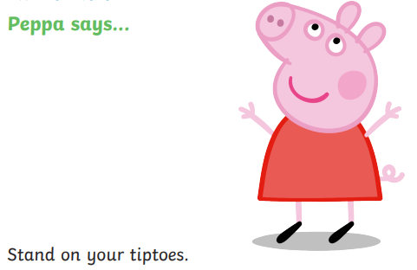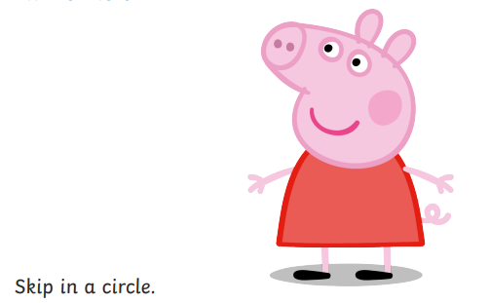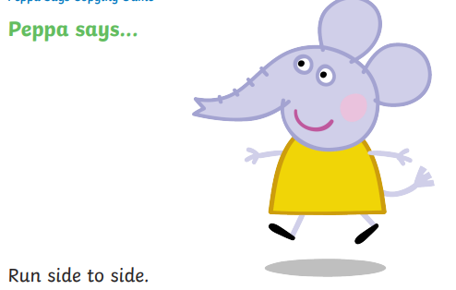
Challenges:
- What other moves can you come up with other than the 6 above? Think about the characters in Peppa Pig and who would you link that new move to?
STEP principle of coaching/teaching- helps to engage, challenge and motivate everyone by altering one or more of the principles
Space - Use the length of your lounge or bedroom for when you are moving around being in character
Task – Can you remember the move and do them again, but better this time?
Equipment – Can you allocate each move to a number on a dice and play it that way?
People – can you challenge a family member to join in or to suggest some new moves?

Target Collect Hand-eye co-ordination
Equipment: Between 5-10 objects (cans of food or plastic cups), 1 pair of balled socks or ball
How to play:
- Set up targets by scattering the objects you have randomly.
- Move away from the objects by taking three big steps backwards.
- Roll the socks or ball along the floor and try to hit the targets.
- When you hit a target, go and collect it and bring it back to where you are standing.
- You can only collect one object at a time.
- The game finishes when you have hit and collected all the objects.

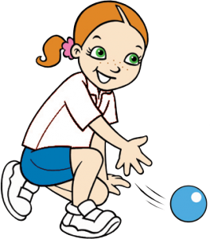

Skill Tip: Keep your eyes on the target! Try to point your hand towards the target as you roll your socks or ball.
Challenges:
- Can you hit the targets by now throwing or kicking your balled socks or ball?

STEP principle of coaching/teaching- helps to engage, challenge and motivate everyone by altering one or more of the principles
Space - Try moving further away from the targets to make it harder.
Task – Can you use a time limit to add pressure on yourself? How many can you hit in 1 minute?
Equipment – Use smaller targets if it’s too easy!
People – Play the game against a member of your family.

Farm Yard Fun Agility
Equipment: none
How to play:
- A adult says an animal command.
- The child quickly thinks about how that animal moves and mimics the animals movements.
- Add animal noises and actions – be as creative as possible.
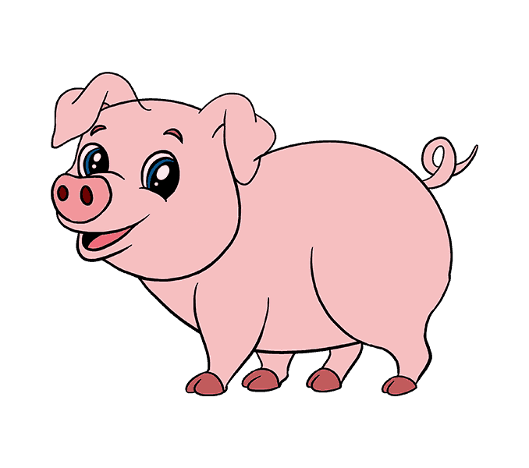
Example;
Horse – galloping
Chicken – flapping their wings
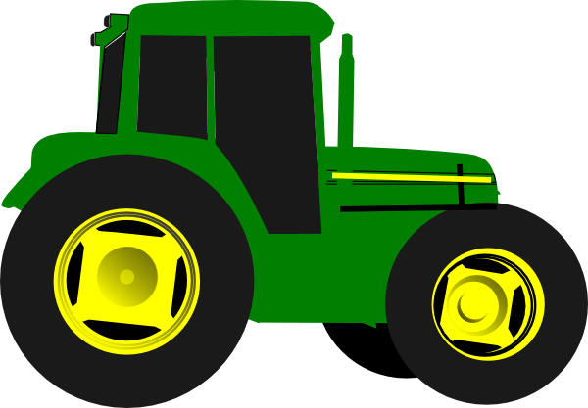
Donkey – on hands kicking legs behind
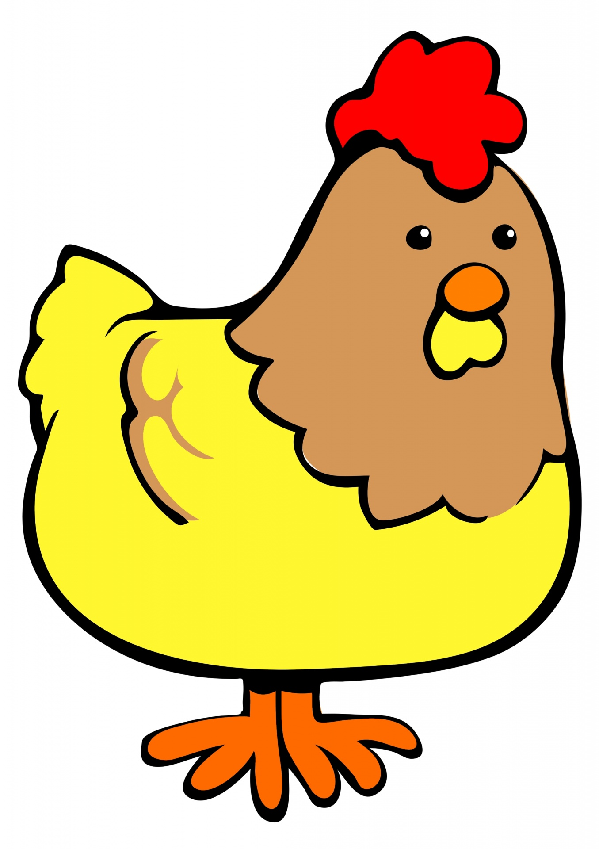
Pig – rolling in mud
Cow – walking on all fours
Tractor – moving arms in a big circle like wheels

Skill Tip: Children may need prompting with ideas or video clips
Challenges:
- Expand to other things you would find on the farm – move like corn in the field, be still like a scarecrow, move hands like a combine-harvester, etc.....

STEP principle of coaching/teaching- helps to engage, challenge and motivate everyone by altering one or more of the principles
Space - Use a larger or smaller space to move around.
Task – Add in direction change e.g. move backwards like a chicken, sideways like a horse galloping, etc...
Equipment – Place objects randomly on the floor for children to move around.
People – Play against a family member; who is the quickest to get into the next movement.

Tight Rope Balance
Equipment: A length of toilet roll (approximately 2-3metres)
How to play:
- Roll out a 2-3 metre length of toilet roll.
- Imagine you are in the circus high above the audience.
- Walk along the ‘tight rope’ toilet roll, keeping your balance.
- Can you walk forwards, backwards and sideways?
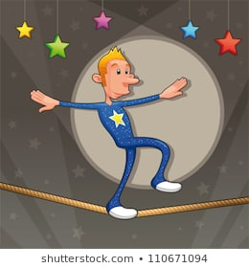

Skill Tip: Keep your arms out stretched at the side of the body, make your body tall and fix your eyes on a spot in front of you.
Challenges:
- Can children explore other ways to travel on the ‘tight rope’? Crawling, jumping, dance steps, etc...

STEP principle of coaching/teaching- helps to engage, challenge and motivate everyone by altering one or more of the principles
Space - Can you try a thinner line to walk along?
Task – Can you close your eyes and still balance on the line?
Equipment – Can you balance a balled pair of socks on your head whilst moving differently?
People – Can you teach your family your movements?

Pirates Treasure Observation & Orienteering skills
Equipment: An object to hide (treasure) , paper & pencil, timer
How to play:
- Ask a family member to hide your treasure in a chosen room.
- Without any clues from your adult, search high and low for your treasure.

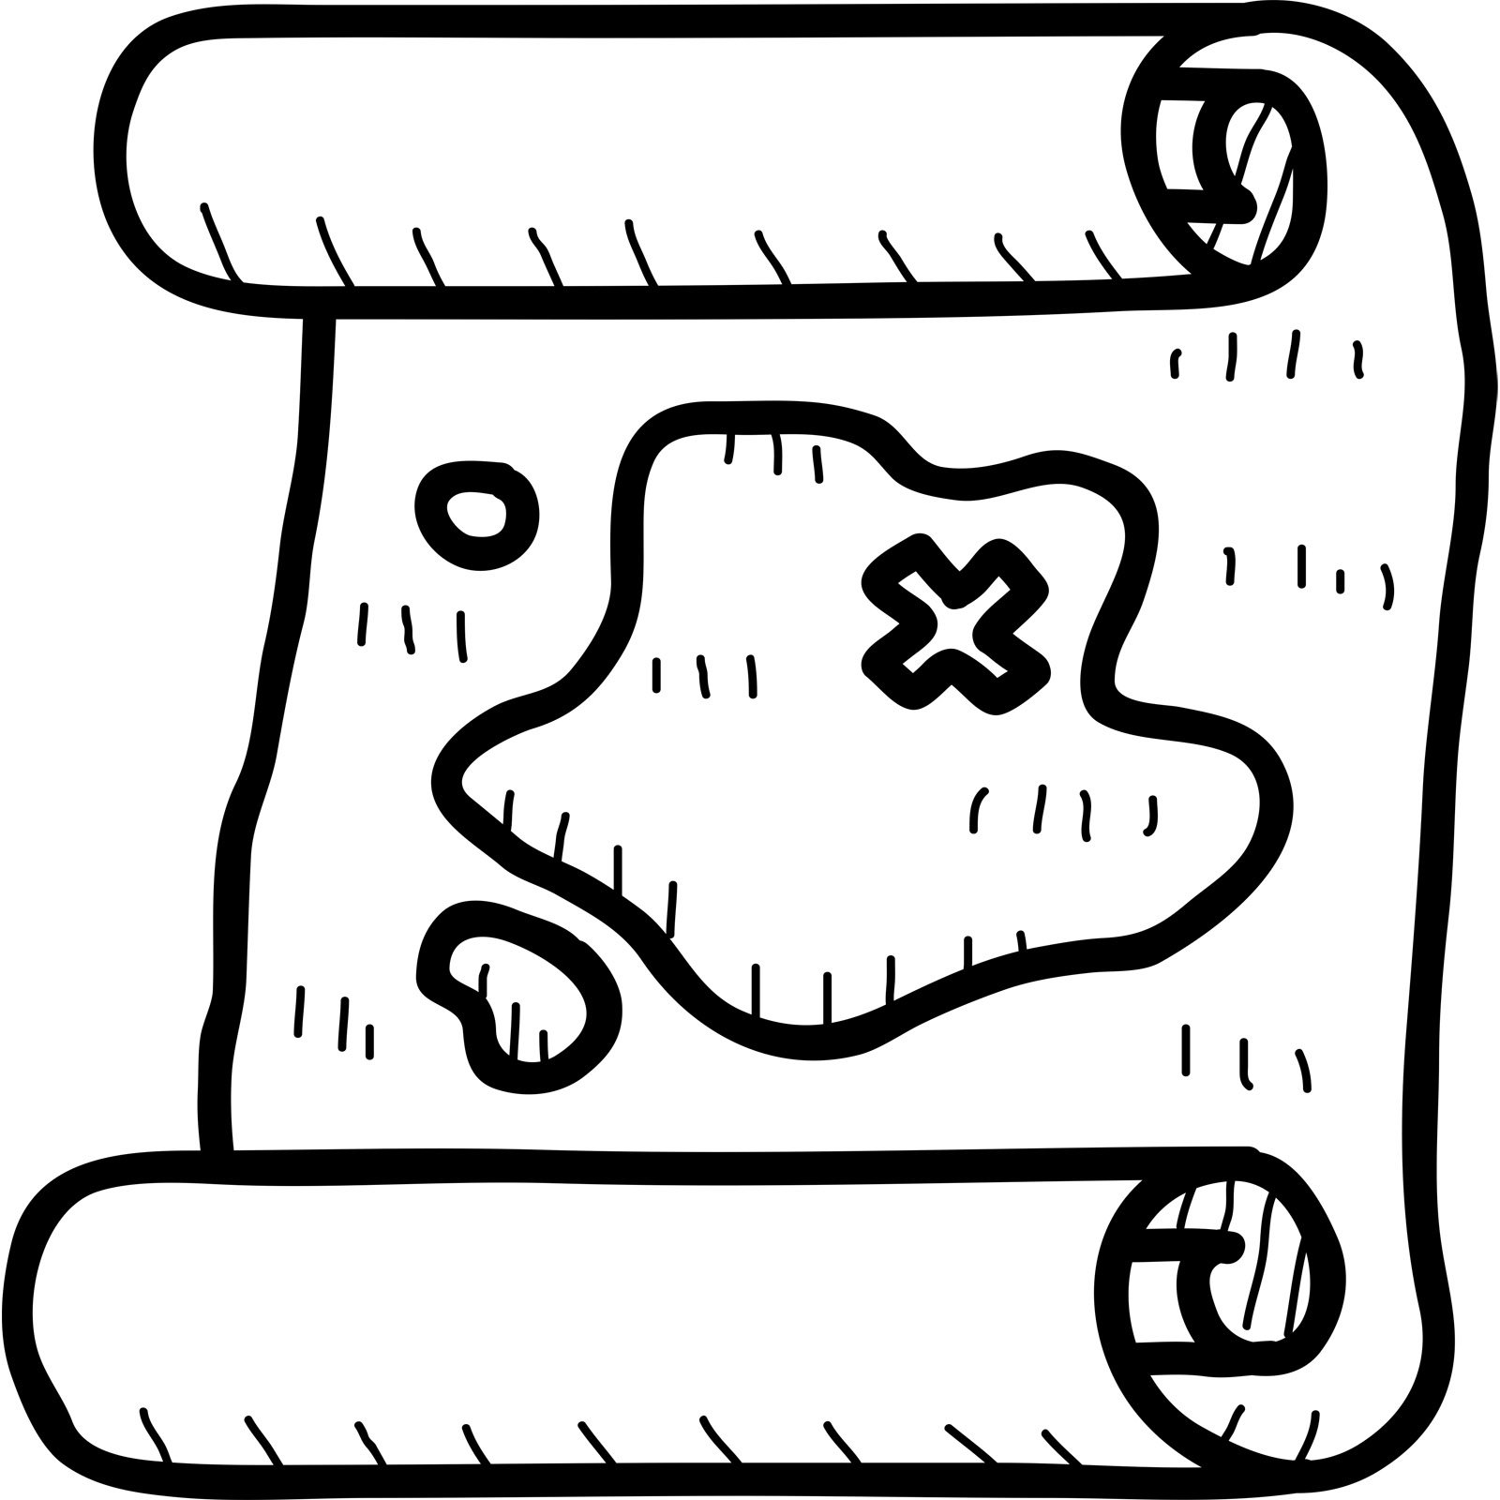
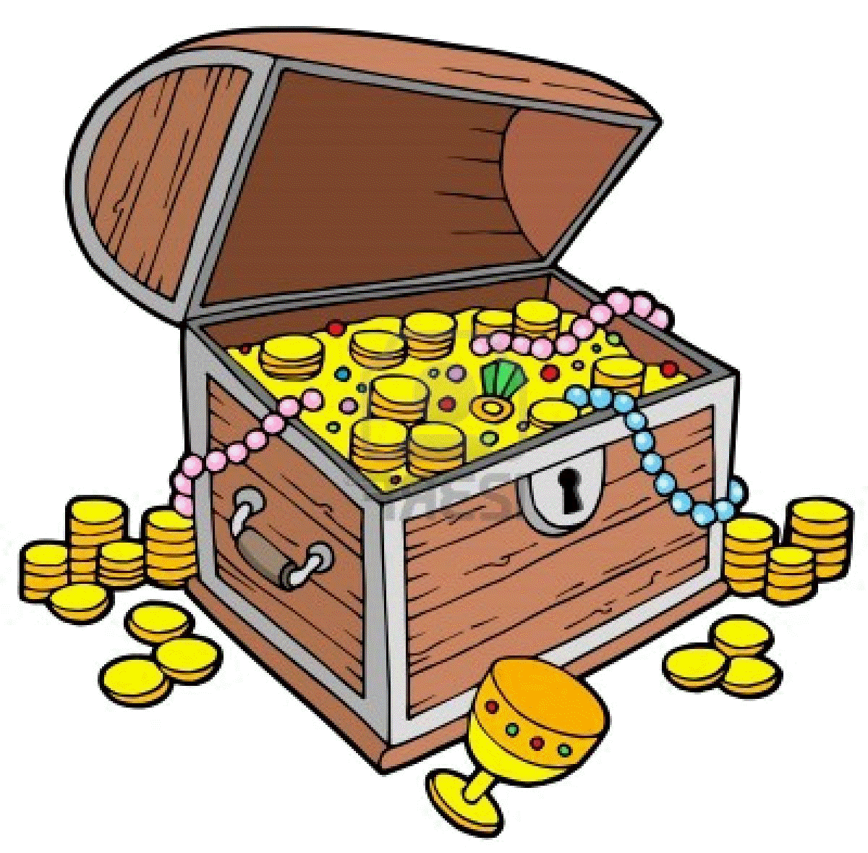

Skill Tip: Search the outside edges of the room first, before looking inside the area. Think of it like a jigsaw – make the edges first, then fill the middle.
Challenges:
- Ask your adult to draw the basic shape of the room, creating a map. When they hide the treasure this time mark with an X where the treasure is hidden on the map. Now use your map to find the treasure.
- Can you take a turn hiding the treasure and marking where it is on the map?

STEP principle of coaching/teaching- helps to engage, challenge, and motivate everyone by altering one or more of the principles
Space - Expand your search area to include other rooms.
Task – Take a turn hiding the treasure for your adult.
Equipment – Can you carry your teddy on your shoulder, like a pirate’s parrot, with you throughout the challenge? Careful not to drop it!!
People – Can you time your family members to see who can find the treasure the quickest?

