SPRING TERM HOME PE
YR 2
Battleships Sending and aiming skills
Equipment: 6 objects to throw at, 2 balls/bean bags or rolled up socks to throw
How to play: 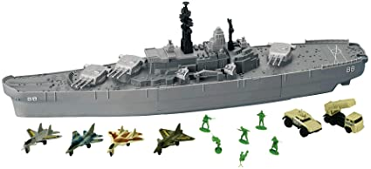

With a partner, each player places three targets (battleships) in front of them.

•Players take turns to throw an object towards their opponent’s battleships.

•Each time a battleship is hit, it is removed.

•Players are not allowed to stop the object from hitting a battleship.

•The winner is the first player to hit all of their partner’s battleships

Challenges:
- Play the game again, but this time can you stand further away from your partners battleships.
- Turn around and find a way of throwing the socks backwards.
- Can you add in more battleships so you have 5 targets to hit.

STEP
Space - make the battleships bigger or smaller .
Task – add in more battleships or take them away.
Equipment – use different size balls to hit the battleships
People –Partner can act a goalkeeper to stop the ball/sock etc

Video: https://www.youtube.com/watch?v=ltZDzlEeP_4&list=PLnwoPgo24bhmqV8Y76iXnwYw9T9AlxbqJ&index=4&t=0s

SPRING TERM HOME PE
YR 2
Cross the River Agility, balance skills and problem solving

Equipment: indoor space, cushions/towels (any flat object)

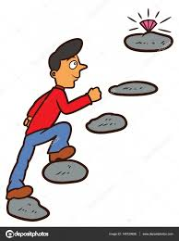
How to play:

Agree a start point (one side of a big river) and a finish point
(the opposite side of the river).
• Using two objects (cushions, pillows, or other flat objects) can you cross
the river without touching the floor?
• You are only allowed two objects to cross the river with.
• Can you complete the challenge and cross the river with out touching the
floor

Challenge: Using a stop watch or clock can you time how long it takes you to cross the river.
STEP
Space – Make the area bigger you have to cross
Task – change the rules, try jumping or hopping to each stepping stone.
Equipment – can you add in something you have to climb over as well?
People – Play follow the leader with a friend.

Video: https://www.youtube.com/watch?v=xp5ClsXs-b8&list=PLnwoPgo24bhmqV8Y76iXnwYw9T9AlxbqJ&index=8&t=0s

SPRING TERM HOME PE
YR 2
Jumping Dice Agility, balance, Coordination

Equipment: A dice,

How to play:
Play with a partner, take turns to roll a dice.
• Look at the number you have rolled and then complete the correct jumping exercises:
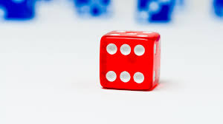
Roll a 1 = Perform 10 star jumps
Roll a 2 = Perform 10 tuck jumps
Roll a 3 = Perform 10 straight jumps
Roll a 4 = Perform 10 frog jumps
Roll a 5 = Perform 10 hops
Roll a 6 = Perform 10 high knees
• The first player to complete all of the activities listed above is the winner.

Challenge: Can you do 20 of each?

STEP
Space – can you do more or less jumps depending on your ability?
Task – change the rules, can you do it with different moves of animals 1 = rabbit, 2 = snake 3 = giraffe 4 = frog 5 = cheetah 6 = bird
Equipment – use a bigger dice
People – can play by yourself, how quickly can you complete all the tasks?

SPRING TERM HOME PE
YR 2
Target Treasure Aiming and sending skills

Equipment: 5 large objects, 2 balls/socks/beanbags

How to play:
Place a selection of targets 5 large steps away from your starting line.
• Players take turns to throw an object towards the targets from
behind the starting line.
• Each time a target is hit, it is taken by the thrower and becomes
their treasure.
• The winner is the player to have the most pieces of treasure after all the treasure is gone.

Challenge: Have more treasures to hit, move further away from the treasure.

STEP
Space – move closer or further away from the treasure.
Task –Can you throw with your non-throwing hand?
Equipment – Make the treasure smaller or bigger to make it harder or easier.
People – Play by yourself to beat your best time.

Video: https://www.youtube.com/watch?v=N9XU5YKLbx8&list=PLnwoPgo24bhmqV8Y76iXnwYw9T9AlxbqJ&index=32&t=0s

SPRING TERM HOME PE
YR 2
Obstacle Course Problem solving, flexibility and balance

Equipment: As many items that you can find – cushions, teddies, socks, jumper etc

How to Play:
How many obstacles can you run around or jump over in 6o seconds?
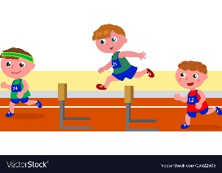
Be creative.
Place out objects; pillows, teddies around your space.
Each time you jump over an object you get a point.
45 points is gold, 30 is silver and 15 is bronze.

Challenge: Could you do it for 2 minutes and see if you can double your score?

Space – Make your space bigger, can you use 2 rooms?
Task – After you jump over an object you have to do 5 star jumps after it.
Equipment – Use higher or lower pieces of equipment.
People – Ask a member of the family to officiate and time you around the course, can you beat your personal best?

SPRING TERM HOME PE
YR 2
Balloon Games Sending, attacking, and defending skills

Equipment: a balloon and something to make a net

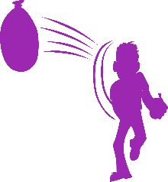
How to start:
First practice the skills you need for the game.
Have a balloon per player and practice keeping it in the air above your head with your hands. How long can you keep it in the air for?

With your partner can you keep the balloon off the ground for 1 minute?
Can you hit the balloon in the air, turn around, touch the ground and hit it in the air again?

Playing the game:
You will need a balloon. To make the net, draw a line on the floor using string or cushions or something long and straight in the house.
Players stand either side of the net. Practice sending the ball over the net and keeping it in the air.
To play, one player starts with the balloon and serves it over the net, the receiving player must return the balloon back over the net without letting it touch the floor.
You may tap, push, hit the balloon back over the net, with any part of the body, but not catch it?
One point for the player who manages to outwit their opponent and get the balloon to land on their opponents’ floor.
You can move around the court. First player to 11 points, wins the game.

Skill Tip: Hit the balloon underneath to make it go up in the air , strike the balloon in the middle to make it go straight and hit the top of the balloon, if you want it to go straight down.
Challenge: Have 2 players on each side and you must pass the balloon at least once to each other before it goes over the net.
Space- make the court smaller or bigger
Task – change the rules of the game – allowed to catch and send back, allowed two taps before sending back
Equipment - make the net higher – tie the string around the leg of two chairs ?
People - Have more people in each team if you have more people at home

SPRING TERM HOME PE
YR 2
Space Adventure creative

Equipment: music

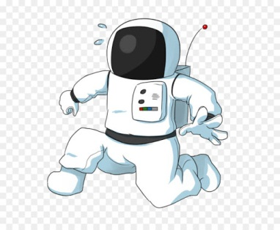
How to play:

• Select some music that makes you think of space, astronauts and aliens.
• Create an action that represents the following movements.
1: Taking off in a space ship.
2: Landing a spaceship on a planet.
3: Exploring your new plant.
4: Making an exciting discovery.

• Add your 4 movements to create a sequence. Perform your sequence to someone else. What do they think?

Top Tips Use big movements! Imagine you are an astronaut! What would they wear? How would they move? Make your movements big and clear. This is your adventure so be creative!

Challenge: Can you change the music so it is faster or slower? Which is harder?
Space : Can you use a bigger space, make movement bigger? Can you use a smaller space?
Task : Teach someone else your dance, can they copy your moves?
Equipment : Change to music
People : Can you do it in sync with a partner, can you teach them your dance?

Video : https://www.youtube.com/watch?v=6g3DA6CIyNk&list=PLnwoPgo24bhmqV8Y76iXnwYw9T9AlxbqJ&index=29&t=0s

SPRING TERM HOME PE
YR 2
Rolling penalties Sending skills and coordination

Equipment: cones or something to make posts (jumpers.cushions) a ball.

How to Play:
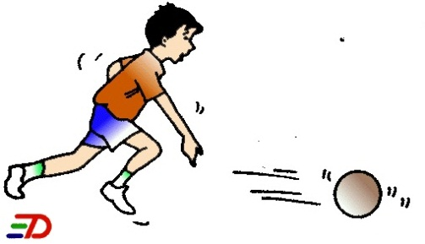
With a partner, set up a goal using two markers.

•Player 1 starts 5 steps away from the goal. Player 2 starts in goal.

•Player 1 rolls the ball towards goal trying to roll the ball past player 2.

•Can player 2 prevent the ball going past them? Can player 1 score?

•Players score a point each time they score a goal. The first to score 5 points is the winner.

Challenge: Make the goals smaller, you can only roll with your weaker hand.

Space : Move further away from each other, or move closer together.
Task : Have 10 goes each who can score the most out of 10? Can you do it with your feet?
Equipment : Make the ball smaller or bigger, change the size of the goals.
People : Take the goal keeper away and just aim to get it between the cones.

SPRING TERM HOME PE
YR 2
Bowling aiming and sending skills
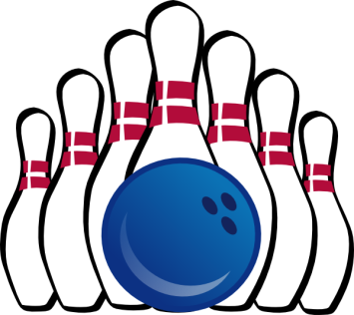
Equipment: 10 empty plastic bottles (or similar to make a target), ball

How to play:
Set up 10 targets at one end of the space; lay these out in a triangle shape.
• Using a ball, each player takes it in turns to roll the ball towards the targets.
• Count how many targets you knocked over then reset for the next turn.
• Each player has 5 turns.
• The winner is the player with the most points at the end.

Top Tip: Rolling Underarm Step forwards with one foot, releasing the ball along the using your opposite hand.

Challenge: move further away from the 10 targets

Space : Move further away to make it harder and move closer to make it easier.
Task : Change how the target is set up, change to a line, or 3 in front of ach other
Equipment : Make targets smaller or bigger.
People : Play in pairs for a team score, or by yourself for a personal best challenge.

Video: https://www.youtube.com/watch?v=AhXbrMPRYGk&list=PLnwoPgo24bhmqV8Y76iXnwYw9T9AlxbqJ&index=2&t=4s

SPRING TERM HOME PE
YR 2
Space Monsters agility and coordination

Equipment: different objects – cones, teddies, cushions etc, a ball that bounces (basketball)

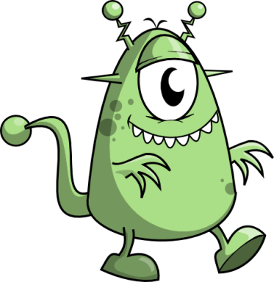
How to play:

Choose a start point and place another marker at the opposite end of the space.
• Layout objects; teddy bears, cones across the playing area.
These are known as the space monsters (defenders).
• Can you dribble using your hands, from the starting point, around the marker
and back avoiding the space monsters?
• If you dribble around the marker and back you score 1 point.

If you hit a space monster they score 1 point. The first to score 5 points is the winner.

Challenge: Increase the number of space monsters you have to get past.

Space : Travel in a larger space or smaller space
Task : Can you do it with your feet?
Equipment : Make the objects smaller to make it easier and bigger to make it harder.
People : Play against someone so they are the space monster.

Video: https://www.youtube.com/watch?v=Wj0RwCe2uxM

