SPRING TERM HOME PE Year 1
TRAFFIC LIGHTS Instruction & Movement skills
Equipment: a little bit of floor space
How to play:
- The aim of the game is to listen to the instructions and complete the movements.
- Each round lasts for 30-60 seconds with someone calling out the instructions.
- Keep doing the same movement until the next instruction is called out!
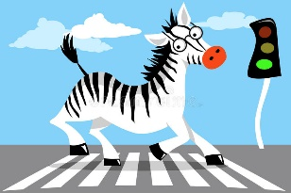
- Round One will start with the three basic instructions;

- Red – Stand still
- Amber – Jog on the spot
- Green – Walk/Jog (depending on floor space)

After each complete round, add two instructions at a time from the following list;

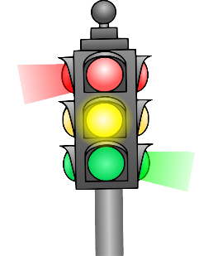
- Roundabout – Spin on the spot once
- Speed Bumps – Jump up and down on the spot
- Reverse – Walk backwards
- Petrol Station – Squat down then jump to the sky continuously
- Low Bridge – get into a press up position with arms straight and hold the position
- High Bridge – Reach up as high as you can and hold the position
- Speed Camera – Move in slow motion
- Motorway – Speed up and move around quicker (depending on floor space)
- Flat Tire – hop around/on the spot (depending on floor space)
- Zebra Crossing – skip around (depending on floor space)

- The round starts when the ‘caller’ shouts ‘Start your engines’ followed by the first instruction.
- See how many rounds you can complete whilst remembering all the correct actions.
- What is your best score today? Try again another day and see if you can get better over the week.
Challenges:
- Play the game again, but this time can you add more of your own instructions. Bear in mind the space you have to play the game.
- Lengthen each round and add more instructions in.
- Can you change the actions for the instructions to challenge yourself further?

STEP
Space – make the playing area bigger or smaller to restrict certain movements. Maybe try it outside.
Task – change the actions of the instructions or make your own up.
Equipment – add an object to act like a steering wheel. Hold a ball whilst completing the actions or add some new instructions to incorporate the equipment added.
People – Test your family members to see how well they can do.

Video - https://www.youtube.com/watch?v=1ICyEjc16Ss

SPRING TERM HOME PE
Year 1
SPEED BOUNCER movement skills
Equipment: an old towel/socks/tie/tape
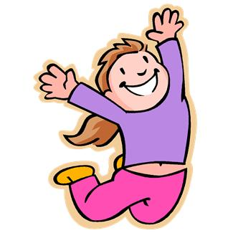
How to play:

- How fast can you jump from side to side?
- This challenge will test your jumping skills…
- Are you ready to bounce?

- Place a rolled up towel or socks/tie/tape, long ways to create a line along the floor

- You must jump with two feet, travel across the line/object marked on the ground, and land with two feet on the other side. That is one completed jump….
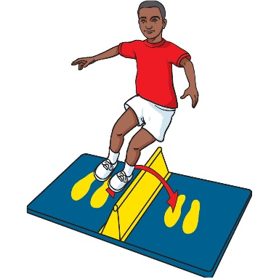
Now the challenges;
How fast can you complete the following;
- 10 jumps
- 20 jumps
- 30 jumps
How many jumps can you complete in the following;
- 10 seconds
- 20 seconds
- 30 seconds

- Write your scores down each time you try, and then try and beat your previous best.
- Make sure you rest between efforts to get your energy back.

Skill Tip: Jump just high enough to cross the towel/line. Be sure not to jump too far across either as this will slow you down. Try and also be light on your feet and use your arms for balance. Remember to keep your head still!!
Challenges:
- Try the challenges each day and see how good you can Speed Bounce!
- Keep your hands close to your body to make it harder to balance
- Use a bigger towel or object to make the jump higher

STEP
Space - make the crawl course bigger or smaller.
Task – with no other obstacles on the floor, shut your eyes for 5 seconds and try and complete a small section of the course
Equipment – A number of old Tee shirts.
People – Time yourself against a friend.

Video https://www.youtube.com/watch?v=_24zvLccN0s

SPRING TERM HOME PE Year 1
AGILITY CHALLENGE Movement skills
Equipment: Toys for markers
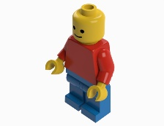
How to play:

Place one toy/object in the middle of the room, this will be your ‘base’.

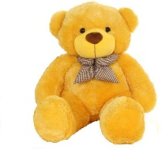
Than using the other Toys/objects place them in different places, all within view. (Start with easy locations, but no closer than 2 metres from the ‘base’ toy/object).

Make sure to name or number each toy/object. (This is to increase difficulty later on).

Begin by standing next to the ‘base’.

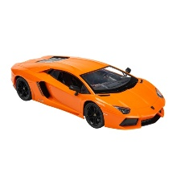
You then have to run to each toy/object, make contact and then return to the ‘base’, continue to do this until you touched every object once.

Finish by returning to the ‘base’.

You may wish to time yourself and aim to beat it.

Skill Tips: Stay in a strong low body position when moving to each toy/object. This will maintain your balance and allow you to push off through your legs to the next toy/object.

What is your best time today? Try again another day and see if you can get better over the week.
Challenges:
- Play the game again, but move/add toys/objects to different locations.
- Add obstacles if you have the space.
- At the start, close your eyes and get someone to move the objects.
- Change the way your allowed to move (hop, skip, bear crawl, jump etc).
- Get someone to call out an object to touch or a sequence you have to complete the touching of each toy in.
- STEP
Space - make the distances bigger or smaller.
Task – Alternate hands when contacting each toy/object.
Equipment – try different objects or carry something with you.
People – Race against a friend

SPRING TERM HOME PE
Year 1
BALL SKILL CHALLENGES Ball skills
Equipment: tennis ball/bouncy ball/small basketball/pair of socks.
How to play:

Try the following skills with your ball and see how many you can complete in a set period of time!
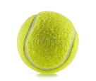
- Drop Ball, let it bounce, than catch.
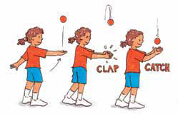
- Drop Ball, clap your hands, and let it bounce than catch.
- Throw Ball up and catch.
- Throw Ball up, clap hands, than catch.
N.B. ball/object dependant as to what skill you can attempt

How many can you do in 60 seconds?

Skill Tip: Keep your eye on the ball and make your hands as big as possible, watch the ball into your hands.

What is your best score today? Try again another day and see if you can get better over the week.

Challenges:
- Play the game again, but only use one hand to catch & drop/catch the ball with. (ball size dependant)
- Shorten the time you have.
- Try with one foot off the ground.

STEP
Space - make sure there is enough area to play in.
Task – Add more claps or even a spin!
Equipment – try and use a different size/type of ball
People – Count yourself against a friend. Who can record the most?

SPRING TERM HOME PE
Year 1
BODYWEIGHT CIRCUIT balance, flexibility, movement skills
Equipment: stopwatch & some music
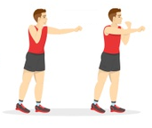
How to play:

You have to complete the sequence in the quickest time possible;

- 20 x running high knees on the spot

- 20 x straight air punches

- 5 x pancakes (1 pancake = from standing position, chest to the floor and back to standing)

- 20 x running high knees on the spot

- 20 x air punches to the sky

- 5 x flap jacks (1 flap jack = from standing position, chest to floor, roll left onto back, roll right back to your front and return to standing)

Challenges:
- Increase of decrease the amount you have to do of each exercise
- Add more rounds
- How many rounds can you complete in a set time?

STEP
Space – move to different areas of your home/garden/park after each exercise
Task – add some different exercises
Equipment – can you add equipment to make exercises harder or easier?
People – work out with a family member!

SPRING TERM HOME PE Year 1
BALANCE TRAINING Balancing & coordination skills
Equipment: Pair of Socks & stop watch
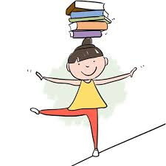
How to play:

Find a nice bit of space at home to complete the balance training…

You can only move onto the next level once you complete the level you are on…

Here we go;

Level 1 – Standing with two feet on the floor, slowly raise one leg up so your knee is in line with your hips, before returning the foot back to the ground. You must complete 10 repetitions on each leg without losing your balance.

Level 2 – Standing with two feet on the floor, slowly take one foot off the ground and balance for 20 seconds. You must complete this on both legs before moving on. If you lose balance and step down before the 20 seconds is up, restart the timer.

Level 3 – Same as level 2 but you must have your eyes closed for the 20 seconds of balancing.

Level 4 – Same as level 2 but a family member has to stand 2 metres in front of you with a rolled up pair of socks. You must complete 5 x throw and catches without losing balance.

Skill Tip: When balancing squeeze your tummy muscles and keep your head as still as possible whilst focussing on a specific point on the wall. Arms can also help with your balance.

What level can you get to? Remember not to progress until you’ve completed the previous level...!

Challenges:
- Take the balance training again, but this time place a thin pillow on the floor to stand on…
- Lengthen or shorten the timings/number of throws.
- Place some objects around you and using the foot not on the floor, try and touch them all without losing balance

STEP
Space - make the area is clear of all objects and obstacles.
Task – have someone asking you questions or read something from the wall to act as a distraction
Equipment – use a different object to throw and catch
People – who can balance for the longest, challenge a friend or family member

SPRING TERM HOME PE
Year 1
Roller Ball co-ordination & movement skills
Equipment: football or something similar
How to play:

Firstly create a course around your home using two objects to make gates, which you will need to pass through.

Then using your hands only you must roll the ball around the course passing through the gates you have created with objects.

All this must be done whilst standing, so bending at the hips and knees will allow you to get low enough to control the ball with your hands…

If your ball hits a wall or an obstacle you must go back to the start.

Skill Tip: Bending at the hips and knees will allow you to get low enough to control the ball with your hands…soft touches on the ball will help.

What is your best time today? Try again another day and see if you can get better over the week.

Challenges:
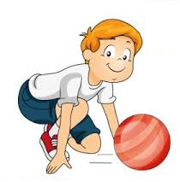
- Play the game again, but change the course and add obstacles
- Can you add a second ball to control around the course?
- Try with only using one hand.

STEP
Space - make the area bigger or smaller
Task – extend the length of the course. Add changes of direction to the course.
Equipment – change the size of the ball
People – Time yourself against a friend

SPRING TERM HOME PE
Year 1
Alphabet Workout movement & problem solving skills
Equipment: 10 x pieces of paper
How to play:

Using the 10 pieces of paper, write a big letter from the alphabet on each piece of paper.

Stack the 10 pieces of paper into a pile at one end of the room/house, this is called ‘Scoring Zone’

Starting at ‘Home’ which will be situated on the opposite side of the room/house, you have to run to the ‘Scoring Zone’ and pick up the first piece of paper and place it on the floor.

You must return ‘Home’ and complete 5 star jumps before returning to the ‘Scoring Zone’ to pick up the next piece of paper with a letter on….

As you start to place the letters on the floor you must place them in alphabetical order.
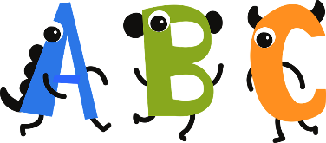
The game finishes when all 10 letters are in the correct order…

Time yourself and see if you can beat your time as you get better at it.

What is your best time today? Try again another day and see if you can get better over the week.
Challenges:
- Play the game again, but this time can you place ‘Words’ into alphabetical order?
- Instead of letters or words, use numbers and place them in numerical order.
- Move in a different way between ‘Home’ and ‘Scoring Zone’ (hop, skip, bear crawl etc)

STEP
Space - make sure the area is clear of objects and obstacles.
Task – change the task in the scoring zone (letter, words, numbers, sums etc)
Equipment – can you add equipment to increase the difficulty?
People – Time yourself against a friend.

SPRING TERM HOME PE
Year 1
JIG-SAW PUZZLE HUNT movement & problem solving skills
Equipment: a picture (a Christmas card or something similar)
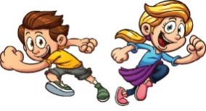
How to play:

Cut a picture up into a number of pieces, of equal size, creating a jig-saw puzzle.

Place one piece of the puzzle in a different room of the house (or spread them out in one room)

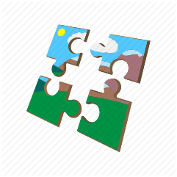
On ‘Go’ you must locate one piece of the puzzle at a time and bring back to a centre point to put back together the jig-saw.

The game finishes once the jig-saw puzzle is completed.

How quickly can you put the puzzle back together

What is your best score today? Try again another day and see if you can complete the puzzle in a quicker time.
Challenges:
- Cut the picture up into different shapes and sizes.
- Use more than one picture at a time.
- Hide the pieces to increase the difficulty

STEP
Space - make sure the area is clear of objects.
Task – different pictures/puzzles/problems to solve
Equipment – add equipment to increase difficulty (egg & spoon for example) (boiled egg!!!)
People – Time yourself against a friend.

SPRING TERM HOME PE
Year 1
BOTTLE BOWLING Throwing & target skills
Equipment: Empty plastic bottle or similar for targets, and socks
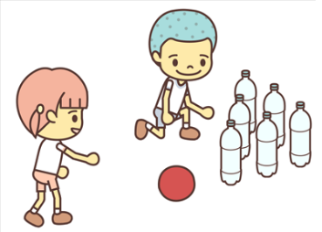
How to play:

Set up the bottles or objects similar to a ten-pin bowling game.

Create a line from which you must stay behind.

Using a rolled up pair of socks, under-arm throw them to hit the bottles/objects over.

Each round you get two throws. After each round you re-set the bottles to their starting position.

Keep a record of how many you knock over in the rounds you play.

Skill Tip: Keep your eye on the target when throwing, and after releasing the socks point to the target.

What is your best score today? Try again another day and see if you can get better over the week.

Challenges:
- Play the game again, this time change the position of the bottles/objects to make it easier or harder
- Add more targets and obstacles
- Can you try it with your eyes closed?

STEP
Space – move closer or further away from the targets
Task – use your non-dominant hand to throw
Equipment – smaller and bigger targets
People – play against a friend.

