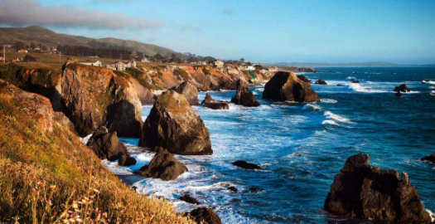
Coastal Wildlife

Have a think about all the different types of wildlife that can be found around the coasts in the UK.
Some examples: different types of seabirds, seals, crabs, sea urchins etc.

Choose 1 and write a fact sheet about it.
You might want to include where it can be found in the UK and why it lives there- does it need certain conditions to survive? How many there are in the UK? How long they live for? Are they predators/prey or both?
Or any other fun facts you can find out.

