Debden Church of England Primary School

Mathematics Policy



Calculation Policy
April 2016

Whole School Calculation Policy

This calculation policy has been written to meet requirements of the National Curriculum 2014 for the teaching and learning of mathematics, and is also designed to give pupils a consistent and smooth progression of learning in calculations throughout the school.

Please note that early learning in number and calculation in Reception follows the “Development Matters” EYFS document, and this calculation policy is designed to build on progressively from the content and methods established in the Early Years Foundation Stage

Philosophy

A high quality Mathematics education provides a foundation for understanding the world, the ability to reason mathematically, and a sense of excitement and curiosity about the subject. As pupils learn Mathematics, they need to acquire fluency in procedures and develop a conceptual understanding.

Understanding how to calculate is an integral part of mathematics and pupils need to be taught through stages in order for them to secure a full understanding of the four number operations.

Aims of the Policy:

- To ensure consistency and progression in our approach to calculation
- To ensure that children develop an efficient, reliable, formal written method of calculation for all operations
- To ensure that children can use these methods accurately with confidence and understanding
- To ensure children are equipped with the necessary understanding in order to select the most appropriate method for calculation

How to Use this Policy:

- Use the policy as the basis of your planning but ensure you use previous or following years’ guidance to allow for personalised learning
- Always use formative assessment to identify suitable next steps in calculation for groups of children
- If, at any time, children are making significant errors, return to the previous stage in calculation
- Always use suitable resources, models, objects and images to support children’s understanding of calculation and place value, as appropriate
- Encourage children to make sensible choices about the methods they use when solving problems
- Encourage children to explain each step of their calculations, in order to assess full understanding

Whole School Objectives for Calculation:

Age stage expectations

The calculation policy is organised according to age stage expectations as set out in the National Curriculum 2014, however it is vital that pupils are taught according to the stage that they are currently working at, being moved onto the next level as soon as they are ready, or working at a lower stage until they are secure enough to move on.

ADDITION:

In developing a written method for addition, it is important that children understand the concept of addition, in that it is:
- Combining two or more groups to give a total or sum
- Increasing an amount

They also need to understand and work with certain principles, i.e. that it is:
- the inverse of subtraction
- commutative i.e. 5 + 3 = 3 + 5
- associative i.e. 5 + 3 + 7 = 5 + (3 + 7)

The fact that it is commutative and associative means that calculations can be rearranged, e.g.
4 + 13 = 17 is the same as 13 + 4 = 17.

SUBTRACTIOn:

In developing a written method for subtraction, it is important that children understand the concept of subtraction, in that it is:
- Removal of an amount from a larger group (take away)
- Comparison of two amounts (difference)

They also need to understand and work with certain principles, i.e. that it is:
- the inverse of addition
- not commutative i.e. 5 - 3 is not the same as 3 - 5
- not associative i.e. 10 - 3 - 2 is not the same as 10 - (3 - 2)

MULTIPLICATION:

In developing a written method for multiplication, it is important that children understand the concept of multiplication, in that it is:
- repeated addition

They should also be familiar with the fact that it can be represented as an array

They also need to understand and work with certain principles, i.e. that it is:
- the inverse of division
- commutative i.e. 5 x 3 is the same as 3 x 5
- associative i.e. 2 x 3 x 5 is the same as 2 x (3 x 5)

DIVISION:

In developing a written method for division, it is important that children understand the concept of division, in that it is:
- repeated subtraction
- sharing into equal amounts

They also need to understand and work with certain principles, i.e. that it is:
- the inverse of multiplication
- not commutative i.e. 15 ÷3 is not the same as 3 ÷ 15
- not associative i.e. 30 ÷ (5 ÷ 2) is not the same as (30 ÷ 5) ÷ 2

Resources

- Progression in Calculation Document
  - Organised into four documents, detailing the age related expectations for each number operation.

- Calculation Key Skills Document
  - An overview for the expectations of the key skills for calculation which should be taught and understood by pupils within each year group.

- A range of mathematical resources available within each classroom to support the teaching of calculation e.g. multi link cubes, place value cards, 100 squares, number lines etc.

Monitoring and Evaluation

- The teaching of calculation will be monitored throughout the year by the subject leader, SLT and colleagues.
  - Book Look
  - Formal Book Monitoring

Appendix
- Progression in Calculation Document
- Calculation Key Skills Document
Year 1: Add with numbers up to 20
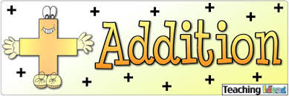
Key vocabulary:
add, more, plus, and, make, altogether, total, equal to, equals, double,
most, count on, number line

Use numbered number lines to add, by counting on in ones. Encourage children to start with the larger number and count on.
+1 +1 +1
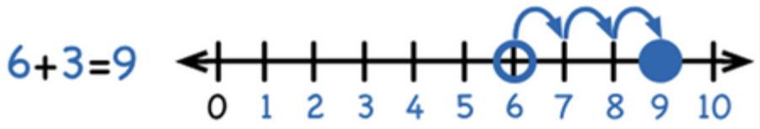

Children should:

- Have access to a wide range of counting equipment, everyday objects, number tracks and number lines, and be shown numbers in different contexts.
- Read and write the addition (+) and equals (=) signs within number sentences.
- Interpret addition number sentences and solve missing box problems, using concrete objects and number line addition to solve them:
8 + 3 =   15 + 4 =   5 + 3 + 1 =    +  = 6
This builds on from prior learning of adding by combining two sets of objects into one group (5 cubes and 3 cubes) in Early Years.

8 + 5 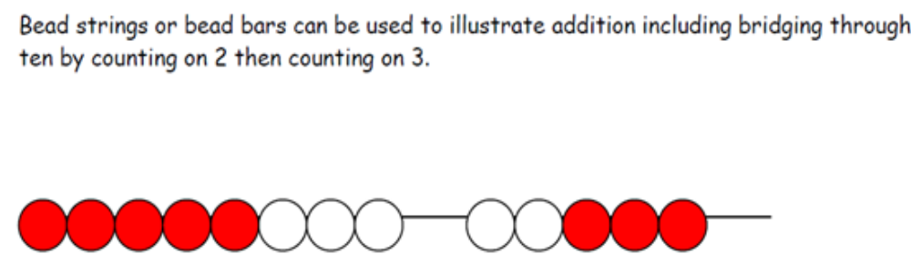

Year 2: Add with 2-digit numbers

Developing mental fluency with addition and place value involving 2-digit numbers, then establish more formal methods.

Key vocabulary:
add, more, plus, and, make, altogether, total, equal to, equals, double, most, count on, number line, sum, tens, units, partition, addition, column, tens boundary

Add 2-digit numbers and tens: Add 2-digit numbers and units:
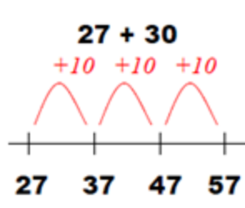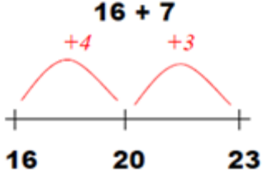
Use empty number lines, concrete equipment,
hundred squares etc. to build confidence and
fluency in mental addition skills.

Add pairs of 2-digit numbers, moving to the partitioned column method when secure adding tens and units:

STEP 1: Only provide examples that do NOT cross the tens boundary until
they are secure with the method itself.

23 + 34:
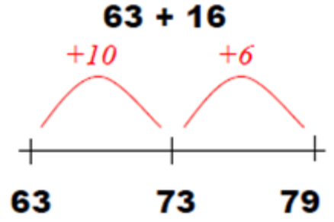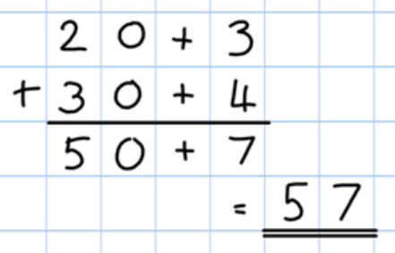

STEP 2: Once children can add a multiple of ten to a 2-digit number mentally (e.g. 80+11), they are ready for adding pairs of 2-digit numbers that DO cross the tens boundary (e.g. 58 + 43).

58 + 43: 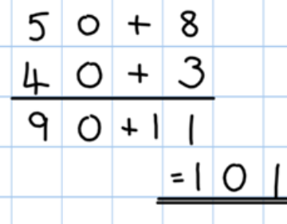

STEP 3: Children who are confident and accurate with this stage should move onto the expanded addition methods with 2 and 3-digit numbers (see Y3).
Year 3: Add numbers with up to 3-digits

Key vocabulary:
add, more, plus, and, make, altogether, total, equal to, equals, double, most, count on, number line, sum, tens, units, partition, plus, addition, column, tens boundary, hundreds boundary, increase, vertical, ‘carry’, expanded, compact

Introduce the expanded column addition method:

Add the units first, in preparation for the compact method.
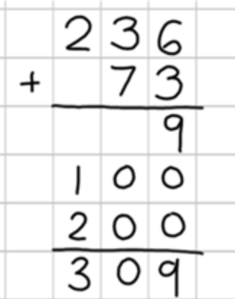
In order to carry out this method of addition:
- Children need to recognise the value of the hundreds, tens and units without recording the partitioning.
- Pupils need to be able to add in columns.

Move to the compact column addition method, with “carrying”:

236
+ 73
309
1

Always add the units first.

Children who are very secure and confident with 3-digit expanded column addition should be moved onto the compact column addition method, being introduced to “carrying” for the first time. Compare the expanded method to the compact column method to develop an understanding of the process and the reduced number of steps involved.
‘Carry’ the numbers underneath the bottom line.

Remind pupils the actual value is “thirty add seventy”, but we say “three add seven” because it is already in the tens column.

Year 4: Add numbers with up to 4-digits

Key vocabulary:
add, more, plus, and, make, altogether, total, equal to, equals, double, most, count on, number line, sum, tens, units, partition, plus, addition, column, tens boundary, hundreds boundary, increase, vertical, ‘carry’, expanded, compact,
thousands, hundreds, digits, inverse

Move from expanded addition to the compact column method, adding units first, and “carrying” numbers underneath the calculation. Also include money and measures contexts.

e.g. 3517 + 396 = 3913

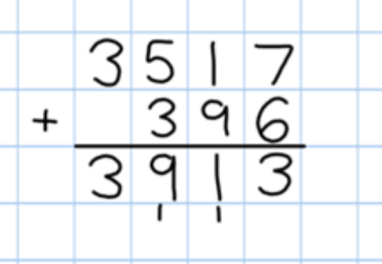
Always add the units first.
‘Carry’ the numbers underneath the bottom line.

Reinforce correct place value by reminding them the actual value is 5 hundreds
add 3 hundreds, not 5 add 3, for example.

Introduce the compact column addition method by asking children to add the two given numbers together using the method that they are familiar with (expanded column addition—see Y3). Teacher models the compact method with carrying, asking children to discuss similarities and differences and establish how it is carried out.

Use and apply this method to money and measurement values.

Year 5: Add numbers with more than 4 digits

Including money, measures and decimals with different numbers of decimal places.

Key vocabulary:
add, more, plus, and, make, altogether, total, equal to, equals, double, most, count on, number line, sum, tens, units, partition, plus, addition, column, tens boundary, hundreds boundary, increase, “carry”, expanded, compact, vertical, thousands, hundreds, digits, inverse, decimal places, decimal point, tenths, hundredths, thousandths

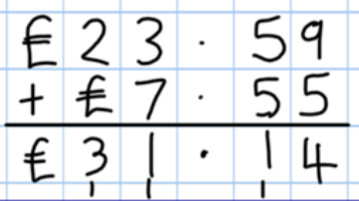
The decimal point should be aligned in the same way as the other place value columns, and must remain in the same column in the answer row.

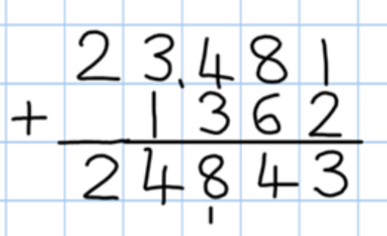
Say “6 tenths add 7 tenths” to reinforce place value.

Numbers should exceed 4 digits.

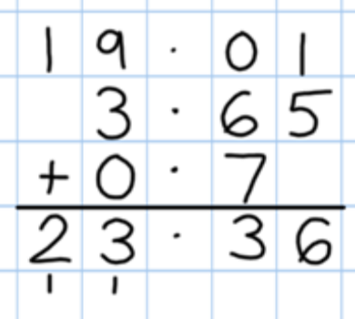
Empty decimal places can be filled with zero to show the place value in each column.
Pupils should be able to add more than two values, carefully aligning place value columns.

Children should:
Understand the place value of tenths and hundredths and use this to align numbers with different numbers of decimal places.

Year 6: Add several numbers of increasing complexity
Key vocabulary:
add, more, plus, and, make, altogether, total, equal to, equals, double, most, count on, number line, sum, tens, units, partition, plus, addition, column, tens boundary, hundreds boundary, increase, ‘carry’, expanded, compact, vertical, thousands, hundreds, digits, inverse, decimal places, decimal point, tenths, hundredths, thousandths

Adding several numbers with different numbers of decimal places (including money and measures):

Tenths, hundredths and thousandths should be correctly aligned, with the decimal point lined up vertically including in the answer row.

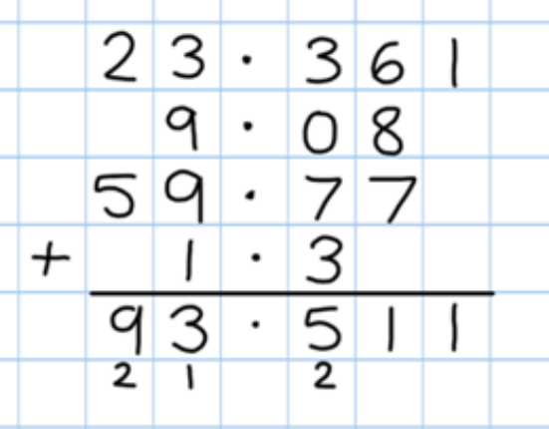
Empty decimal places should be filled with zero to show the place value in each column.

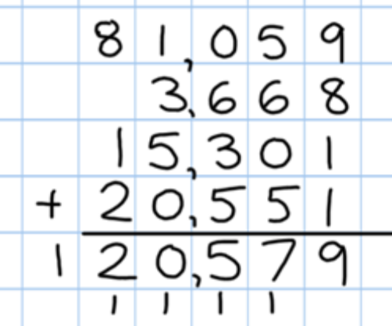

Adding several numbers with more than 4 digits.

Year 1: Subtract from numbers up to 20

Key vocabulary:
equal to, take, take away, less, minus, subtract, leaves, distance between, how many more, how many fewer / less than, most, least, count back , how many left, how much less is_?

Children consolidate understanding of subtraction practically, showing subtraction on bead strings, using cubes etc. and in familiar contexts, and are introduced to more formal recording using number lines as below:

Subtract by taking away
-1 -1 -1 -1
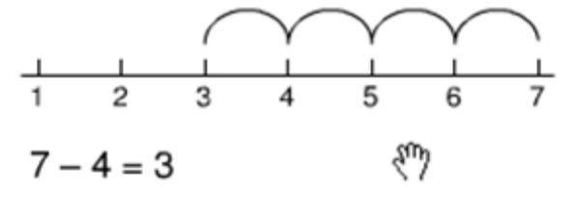
Count back in ones on a numbered number line to take away, with numbers up to 20:

Model subtraction using hundred squares and numbered number lines/tracks and practically.

Find the “distance between”
This will be introduced practically with the language “find the distance between” and “how many more?” in a range of familiar contexts.

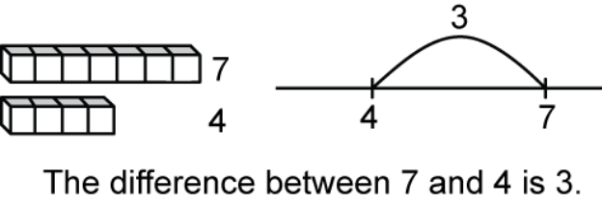

“Seven is 3 more than four”

“I am 3 years older than my sister”

Mental subtraction

Children should start recalling subtraction facts up to and within 10 and 20, and should be able to subtract zero.

Year 2: Subtract with 2-digit numbers
Key vocabulary:
equal to, take, take away, less, minus, subtract, leaves, distance between, how many more, how many fewer / less than, most, least, count back , how many left, how much less is_?
difference, count on, strategy, partition, tens, units

Subtract on a number line by counting back, aiming to develop mental subtraction skills.
This strategy will be used for:
- 2-digit numbers subtract units (by taking away / counting back) e.g. 36—7
- 2-digit numbers subtract tens (by taking away / counting back) e.g. 48—30
- Subtracting pairs of 2-digit numbers (see below:)

47 - 23 = 24 Partition the second number and subtract it in tens and units, as below:

Move towards more efficient jumps back, as below

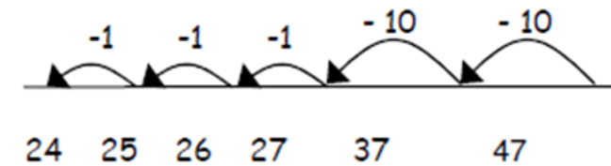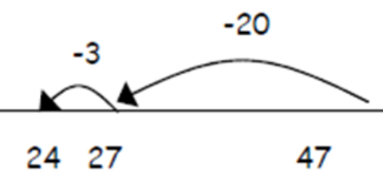

Subtract the tens first…..

:
And then the ones!

Combine methods with use of a hundred square to reinforce understanding of number value and order.

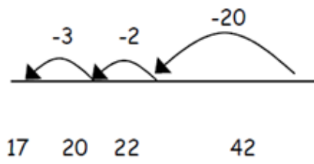
Teaching children to bridge through ten can help them to become more efficient, for example 42 - 25:

Mental strategy - subtract numbers close together by counting on: 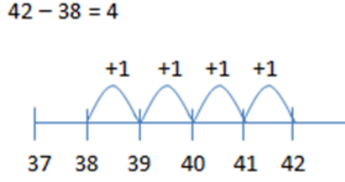
Many mental strategies are taught. Children are taught to recognise that when numbers are close together, it is more efficient to count on the difference. They need to be clear about the relationship between addition and subtraction.

Year 3: Subtracting with 2 and 3-digit numbers.
Key vocabulary:
equal to, take, take away, less, minus, subtract, leaves, distance between, how many more, how many fewer / less than, most, least, count back , how many left, how much less is_?
difference, count on, strategy, partition, tens, units,
exchange, decrease, hundreds, value, digit

STEP 1: introduce this method with examples where no exchanging is required.

89 – 35 = 54
80 + 9
When learning to “exchange”, explore “partitioning in different ways” so that pupils understand that when you exchange, the VALUE is the same ie 72 = 70+2 = 60+12 = 50+22 etc. Emphasise that the value hasn‘t changed, we have just partitioned it in a different way.

- 30 + 5
50 + 4

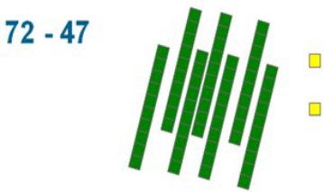
STEP 2: introduce “exchanging” through practical subtraction. Make the larger number with Base 10, then subtract 47 from it.
70 + 2
- 40 + 7
20 + 5 = 25

Before subtracting ‘7’ from the 72 blocks, they will need to exchange a row of 10 for ten units. Then subtract 7, and subtract 4 tens.

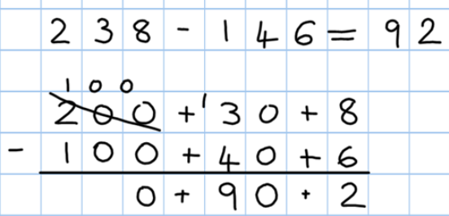
STEP 3: Once pupils are secure with the understanding of ‟exchanging‟, they can use the partitioned column method to subtract any 2 and 3-digit numbers.

Counting on as a mental strategy for subtraction:
Continue to reinforce counting on as a strategy for close-together numbers (e.g. 121—118), and also for numbers that are ‟nearly” multiples of 10, 100, 1000 or £s, which make it easier to count on (e.g. 102-89, 131—79, or calculating change from £1 etc.)
- Start at the smaller number and count on in tens first, then count on in units to find the rest of the difference:
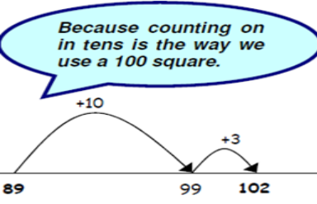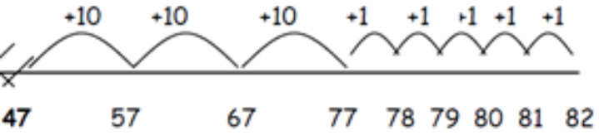

Year 4: Subtract with up to 4-digit numbers
Key vocabulary:
equal to, take, take away, less, minus, subtract, leaves, distance between, how many more, how many fewer / less than, most, least, count back , how many left, how much less is_?
difference, count on, strategy, partition, tens, units, exchange, decrease,
hundreds, value, digit, inverse

Partitioned column subtraction with “exchanging” (decomposition):
As introduced in Y3, but moving towards more complex numbers and values. Use place value counters to reinforce “exchanging”.

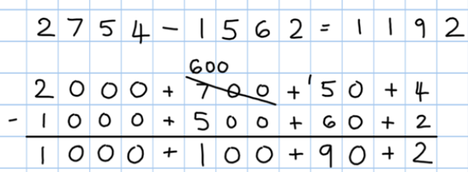

Compact column subtraction
To introduce the compact method, ask children to perform a subtraction calculation with the familiar partitioned column subtraction then display the compact version for the calculation they have done. Ask pupils to consider how it relates to the method they know, what is similar and what is different, to develop an understanding of it.

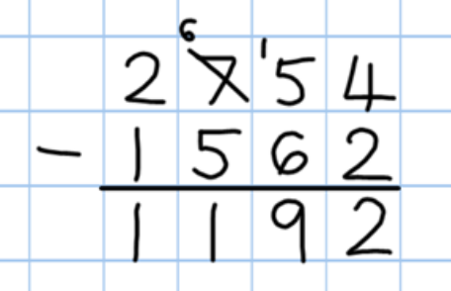

Always encourage children to consider the best method for the numbers involved - mental, counting on, counting back or written method.

Mental strategies
A variety of mental strategies must be taught and practised, including counting on to find the difference where numbers are closer together, or where it is easier to count on.

Year 5: Subtract with at least 4-digit numbers
including money, measures, decimals.
Key vocabulary:
equal to, take, take away, less, minus, subtract, leaves, distance between, how many more, how many fewer / less than, most, least, count back , how many left, how much less is_?
difference, count on, strategy, partition, tens, units, exchange, decrease,
hundreds, value, digit, inverse, tenths, hundredths, decimal point, decimal

Compact column subtraction
Children who are still not secure with number facts and place value will need to remain on the partitioned column method until ready for the compact method.

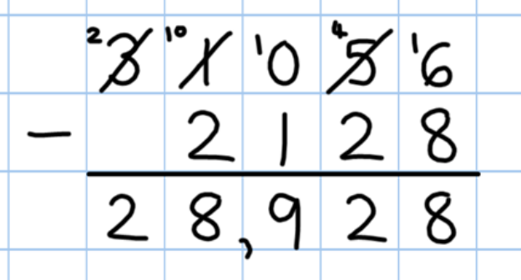 Subtracting with larger integers

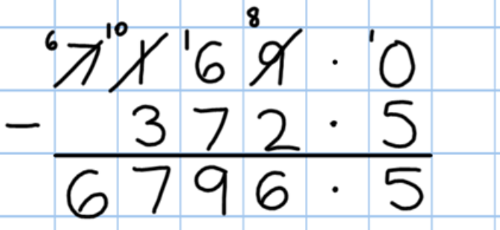
Subtract with decimal values, including mixtures of integers and decimals, aligning the decimal point.

Add a zero in any empty decimal places to aid understanding of what to subtract in that column.

Create lots of opportunities for subtracting and finding differences with money and measures.

Year 6: Subtracting with increasingly large and
more complex numbers and decimal values

Key vocabulary:
equal to, take, take away, less, minus, subtract, leaves, distance between, how many more, how many fewer / less than, most, least, count back , how many left, how much less is_?
difference, count on, strategy, partition, tens, units, exchange, decrease,
hundreds, value, digit, inverse, tenths, hundredths, decimal point, decimal

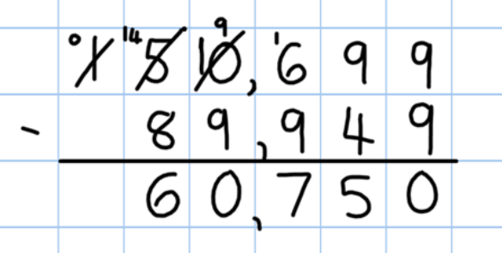
Using the compact column method to subtract more complex integers.
Using the compact column method to subtract money and measures, including decimals with different numbers of decimal places.

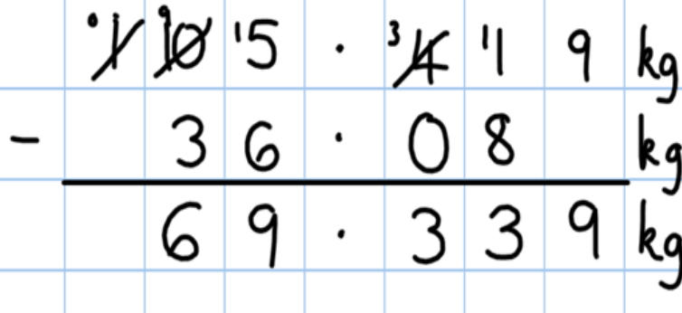
Empty decimal places can be filled with zero to show the place value in each column.

Pupils should be able to apply their knowledge of a range of mental strategies, mental recall skills, and informal and formal written methods when selecting the most appropriate method to work out subtraction problems.

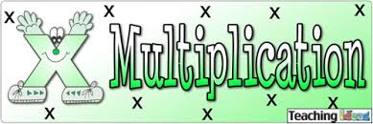

Year 1: Multiply with concrete objects,
arrays and pictorial representations.
Key vocabulary:
groups of, lots of, times, array, altogether, multiply, count

How many legs will 3 teddies have?

 2 + 2 + 2 = 6

There are 3 sweets in one bag. How many sweets are in 5 bags altogether?



- Give children experience of counting equal group of objects in 2s, 5s and 10s.
- Present practical problem solving activities involving counting equal sets or groups, as above.

Year 2: Multiply using arrays and repeated addition
(using at least 2s, 5s and 10s)
Key vocabulary:
groups of, lots of, times, array, altogether, multiply, count, multiplied by, repeated addition, column, row, commutative, sets of, equal groups, times as big as, once, twice, three times...

Use repeated addition on a number line:
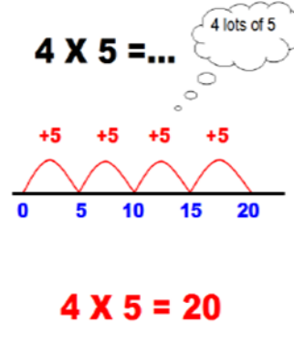
Starting from zero, make equal jumps up on a number line to work out multiplication facts and write multiplication statements using x and = signs.

Use arrays:

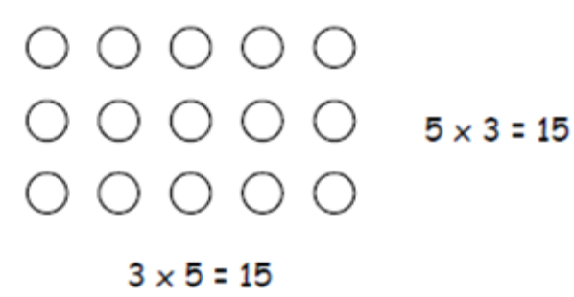
5 x 3 = 3 + 3 + 3 + 3 = 15
3 x 5 = 5 + 5 + 5 = 15

Use arrays to help teach children to understand the commutative law of multiplication, and give examples such as 3 x __ = 6.

Use practical apparatus:

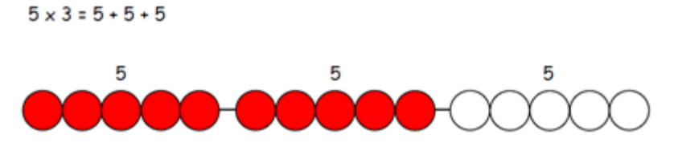

Use mental recall:

Children should begin to recall multiplication facts for 2, 5 and 10 times tables through practice in counting and understanding of the operation.

Year 3: Multiply 2-digits by a single digit number
Key vocabulary:
groups of, lots of, times, array, altogether, multiply, count, multiplied by, repeated addition, column, row, commutative, sets of, equal groups, times as big as, once, twice, three times...
partition, grid method, multiple, product, tens, units, value

Introduce the grid method for multiplying 2-digit by single-digits:

Link the layout of the grid to an array initially
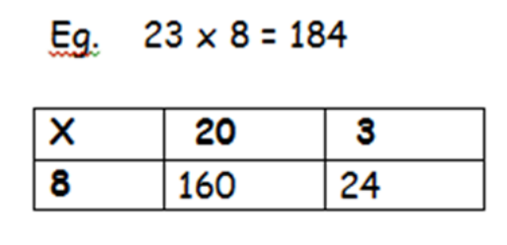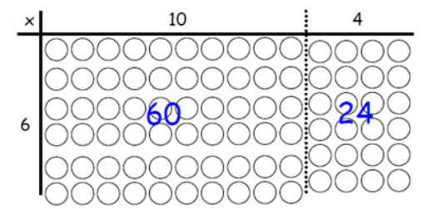
Introduce the grid method with children physically making an array to represent the calculation (e.g. make 8 lots of 23 with 10s and 1s place value counters), then translate this to grid method format.

To do this, children must be able to:
- Partition numbers into tens and units
- Multiply multiples of ten by a single digit (e.g. 20 x 4) using their knowledge of multiplication facts and place value
- Recall and work out multiplication facts in the 2, 3, 4, 5, 8 and 10 times tables.
- Work out multiplication facts not known by repeated addition or other taught mental strategies (e.g. by commutative law, working out near multiples and adjusting, using doubling etc.) Strategies to support this are repeated addition using a number line, bead bars and arrays:

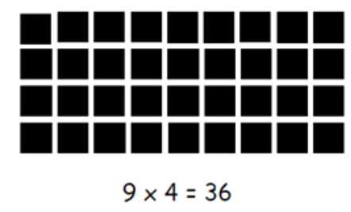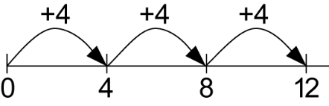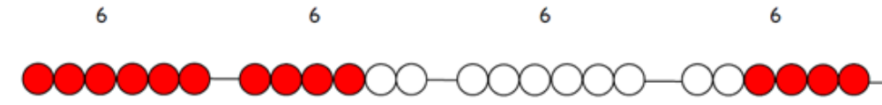

Year 4: Multiply 2 and 3-digits by a single digit,
(using all multiplication tables up to 12 x 12)

Key vocabulary:
groups of, lots of, times, array, altogether, multiply, count, multiplied by, repeated addition, column, row, commutative, sets of, equal groups, times as big as, once, twice, three times...
partition, grid method, multiple, product, tens, units, value, inverse

Encourage column addition to add accurately.
Developing the grid method:

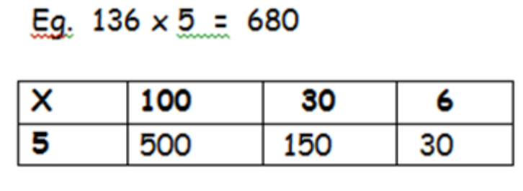
500
150
+ 30
680
Move onto short multiplication (see Y5) if and when children are confident and accurate multiplying 2 and 3-digit numbers by a single digit this way, and are already confident in ‟carrying” for written addition.

Children should be able to:

- Approximate before they calculate, and make this a regular part of their calculating, going back to the approximation to check the reasonableness of their answer.
e.g:
346 x 9 is approximately 350 x 10 = 3500

- Record an approximation to check the final answer against.

- Multiply multiples of ten and one hundred by a single-digit, using their multiplication table knowledge.
- Recall all times tables up to 12 x 12

Year 5: Multiply up to 4-digits by 1 or 2 digits
Key vocabulary:
groups of, lots of, times, array, altogether, multiply, count, multiplied by, repeated addition, column, row, commutative, sets of, equal groups, times as big as, once, twice, three times...
partition, grid method, multiple, product, tens, units, value, inverse,
square, factor, integer, decimal, short/long multi-plication, “carry”

Introducing column multiplication

Introduce by comparing a grid method calculation to a short multiplication method, to see how the steps are related, but notice how there are less steps involved in the column method.

Children need to be taught to approximate first, e.g. for 72 x 38, they will use rounding: 72 x 38 is approximately 70 x 40 = 2800, and use the approximation to check the reasonableness of their answer against.

Short multiplication for multiplying by a single digit
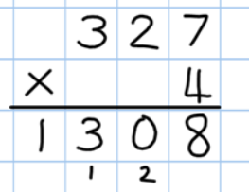

x | 300 | 20 | 7
4 | 1200 | 80 | 28

Pupils could be asked to work out a given calculation using the grid, and then compare it to “your” column method. What are the similarities and differences? Unpick the steps and show how it reduces the steps.

Introduce long multiplication for multiplying by 2 digits

The grid could be used to introduce long
multiplication, as the relationship can be seen in the answers in each row.

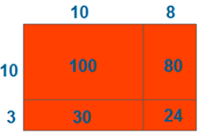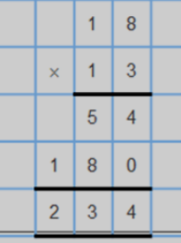

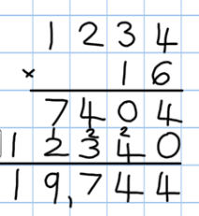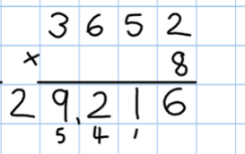
Moving towards more complex numbers:
1234 x 6
1234 x 10

Year 6: Short and long multiplication as in Y5,
and multiply decimals with up to 2 decimal
places by a single digit.

Key vocabulary:
groups of, lots of, times, array, altogether, multiply, count, multiplied by, repeated addition, column, row, commutative, sets of, equal groups, times as big as, once, twice, three times...
partition, grid method, multiple, product, tens, units, value, inverse,
square, factor, integer, decimal, short/long multiplication, “carry”,
tenths, hundredths, decimal

Line up the decimal points in the question and the answer.
Remind children that the single digit belongs in the units column.
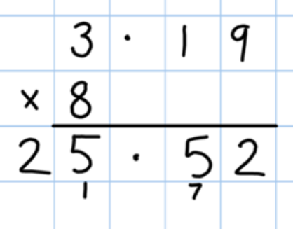
This works well for multiplying money (£.p) and other measures.

Children will be able to:

- Use rounding and place value to make approximations before calculating and use these to check answers against.
- Use short multiplication (see Y5) to multiply numbers with more than 4-digits by a single digit; to multiply money and measures, and to multiply decimals with up to 2d.p. by a single digit.
- Use long multiplication (see Y5) to multiply numbers with at least 4 digits by a 2-digit number.

Year 1: Group and share small quantities 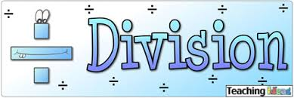

Key vocabulary:
share, share equally, one each, two each…, group, groups of, lots of, array

Using objects, diagrams and pictorial representations to solve problems involving both grouping and sharing.

How many groups of 4 can be made with 12 stars? = 3

Grouping:
Example division problem in a familiar context:

There are 6 pupils on this table and there are 18 pieces of fruit to share between us.

If we share them equally, how many will we each get?

Can they work it out and give a division statement… ?

“18 shared between 6 people gives you 3 each.”


Sharing:
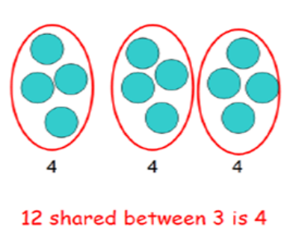

Pupils should :
- Use lots of practical apparatus, arrays and picture representations.
- Be taught to understand the difference between “grouping” objects (How many groups of 2 can you make?) and “sharing” (Share these sweets between 2 people).
- Be able to count in multiples of 2s, 5s and 10s.
- Find half of a group of objects by sharing into 2 equal groups.

Year 2: Group and share, using the ÷ and = sign

Key vocabulary:
share, share equally, one each, two each…, group, groups of, lots of, array,
divide, divided by, divided into, division, grouping, number line, left, left over

Use objects, arrays, diagrams and pictorial representations, and grouping on a number line.

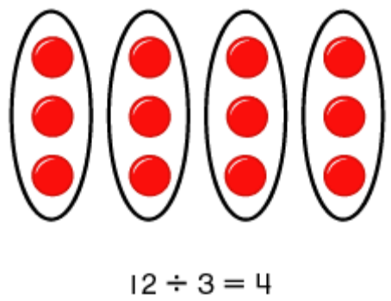
This represents 12 ÷ 3, posed as
how many groups of 3 are in 12?
Pupils should also show that the same array can represent 12 ÷ 4 = 3 if grouped horizontally.

Know and understand sharing and grouping:
Sharing Grouping
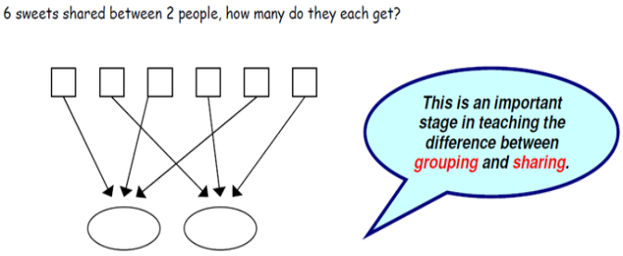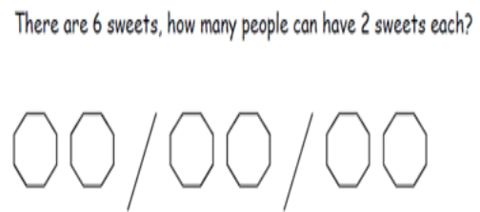

Children should be taught to recognise whether problems require sharing or grouping.

Grouping using a number line:
Group from zero in equal jumps of the divisor to find out ‟how many groups of _ in _ ?” Pupils could use a bead string or practical apparatus to work out problems like
“A CD costs £3. How many CDs can I buy with £12?” This is an important method to develop understanding of division as grouping.
+3 +3 +3 +3
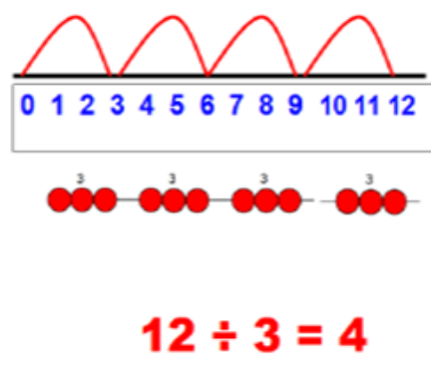Pose 12 ÷ 3 as “How many groups of 3 are in 12?”
Year 3: Divide 2-digit numbers by a single digit
(where there is no remainder in the final answer)
Key vocabulary:
share, share equally, one each, two each…, group, groups of, lots of, array,
divide, divided by, divided into, division, grouping, number line, left, left over,
inverse, short division, “carry”, remainder, multiple

STEP 1: Children continue to work out unknown division facts by grouping on a number line from zero. They are also now taught the concept of remainders, as in the example. This should be introduced practically and with arrays, as well as being translated to a number line.

Grouping on a number line:

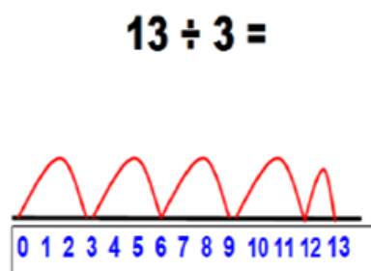
Children should work towards calculating some basic division facts with remainders mentally for the 2s, 3s, 4s, 5s, 8s and 10s, ready for “carrying” remainders across within the short division method.

Short division: Limit numbers to NO remainders in the answer OR carried (each digit must be a multiple of the divisor).
STEP 2: Once children are secure with division as grouping and demonstrate this using number lines, arrays etc., short division for larger 2-digit numbers should be introduced, initially with carefully selected examples requiring no calculating of remainders at all. Start by introducing the layout of short division by comparing it to an array.

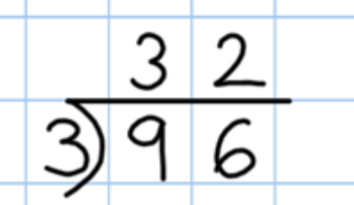

Remind children of correct place value, that 96 is equal to 90 and 6, but in short division, pose: How many 3’s in 9? = 3, and record it above the 9 tens.
How many 3’s in 6? = 2, and record it above the 6 units.

Short division: Limit numbers to NO remainders in the final answer, but with remainders occurring within the calculation.
STEP 3: Once children demonstrate a full understanding of remainders, and also the short division method taught, they can be taught how to use the method when remainders occur within the calculation (e.g. 96÷4), and be taught to “carry” the remainder onto the next digit. If needed, children should use the number line to work out individual division facts that occur which they are not yet able to recall mentally.
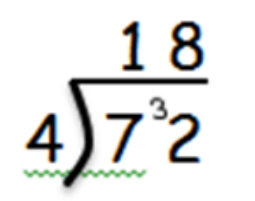
Step 3 Only taught when pupils can calculate “remainders”.
Year 4: Divide up to 3-digit numbers by a single digit
(without remainders initially)
Key vocabulary:
share, share equally, one each, two each…, group, groups of, lots of, array,
divide, divided by, divided into, division, grouping, number line, left, left over,
inverse, short division, “carry”, remainder, multiple, divisible by, factor

Short division should only be taught once children have secured the skill of calculating “remainders”.
Continue to develop short division:

STEP 1: Pupils must be secure with the process of short division for dividing 2-digit numbers by a single digit (those that do not result in a final remainder - see steps in Y3), but must understand how to calculate remainders, using this to “carry” remainders within the calculation process (see example).

STEP 2: Pupils move onto dividing numbers with up to 3-digits by a single digit, however problems and calculations provided should not result in a final answer with remainder at this stage. Children who exceed this expectation may progress to Y5 level.
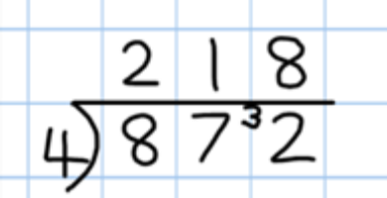
Include money and measure contexts when confident.

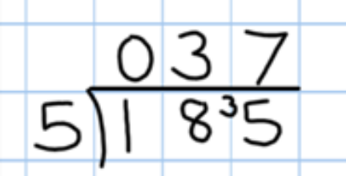
When the answer for the first column is zero (1 ÷ 5, as in example), children could initially write a zero above to acknowledge its place, and must always “carry” the number (1) over to the next digit as a remainder.

Real life contexts need to be used routinely to help pupils gain a full understanding, and the ability to recognise the place of division and how to apply it to problems.

Year 5: Divide up to 4 digits by a single digit,
(including those with remainders.)

Key vocabulary:
share, share equally, one each, two each…, group, groups of, lots of, array,
divide, divided by, divided into, division, grouping, number line, left, left over,
inverse, short division, “carry”, remainder, multiple, divisible by, factor,
quotient, prime number, prime factors, composite number (non-prime)

Short division, including remainder answers:

Short division with remainders: Now that pupils are introduced to examples that give rise to remainder answers, division needs to have a real life problem solving context, where pupils consider the meaning of the remainder and how to express it, ie. as a fraction, a decimal, or as a rounded number or value , depending upon the context of the problem.
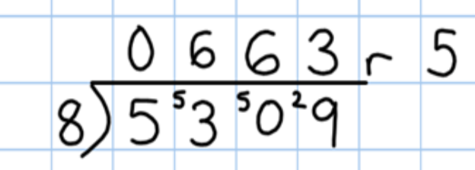

The answer to 5309 ÷ 8 could be expressed as 663 and five eighths,
663 r 5, as a decimal, or rounded as appropriate to the problem involved.

Include money and
measure contexts.

If children are confident and accurate:

- Introduce long division for pupils who are ready to divide any number by a 2-digit number (e.g. 2678 ÷ 19). This is a Year 6 expectation.

Year 6: Divide at least 4 digits by both single-digit
and 2-digit numbers (including decimal numbers and
quantities)

Key vocabulary:
share, share equally, one each, two each…, group, groups of, lots of, array,
divide, divided by, divided into, division, grouping, number line, left, left over,
inverse, short division, “carry”, remainder, multiple, divisible by, factor,
quotient, prime number, prime factors, composite number (non-prime),
common factor

Short division, for dividing by a single digit: e.g. 6497 ÷ 8
Short division with remainders: Pupils should continue to use this method, but with numbers to at least 4 digits, and understand how to express remainders as fractions, decimals, whole number remainders, or rounded numbers.
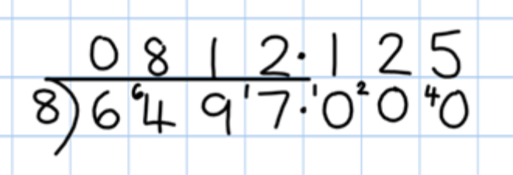

Real life problem solving contexts need to be the starting point, where pupils have to consider the most appropriate way to express the remainder.

Introduce long division by chunking for dividing by 2 digits.
Find out “How many 36s are in 972?” by subtracting “chunks” of 36, until zero is reached (or until there is a remainder).
- Teach pupils to write a “useful list” first at the side that will help them decide what chunks to use, e.g.:

Useful list: 1x = 36 10x = 360 100x = 3600

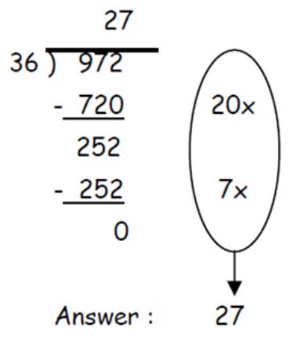
Must be aligned in place value for subtracting.
.

Where remainders occur, pupils should express them as fractions, decimals or use rounding, depending upon the problem.
Introduce the method in a simple way by limiting the choice of chunks to: Can we use 10 lots? Can we use 100 lots? As children become confident with the process, encourage more efficient chunks to get to the answer more quickly (e.g. 20x, 5x), and expand on their “useful” lists.

