Year Two – Parts of a flowering plant
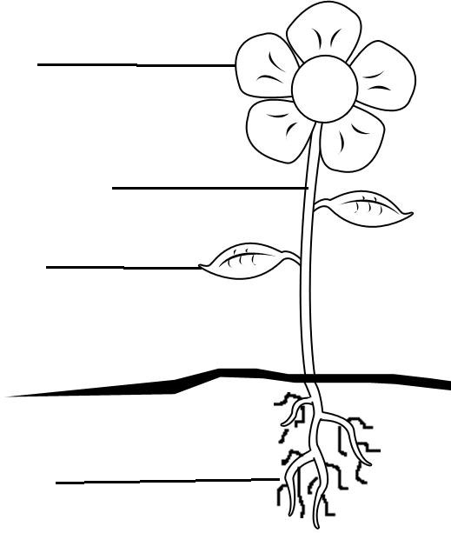

ROOTS STEM LEAVES FLOWER

roots leaves flowers stem
The on a plant produce seeds which form new plants.
The make the food for the plant. They take the water and minerals and use them together with sunlight and carbon-dioxide to make food. This is called photosynthesis.
The is like a straw. It moves water around the plant. It raises the leaves and flowers of the plant off the ground.
The take in water and minerals from the soil. They anchor the plant into the ground.

