Who helps us stay healthy and safe?

Look at the photographs of the different people below.
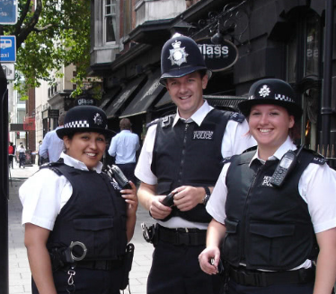
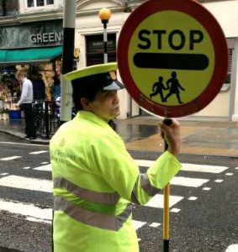
The photographs show the following:
- Teacher
- Doctor
- Police
- Crossing patrol
- Firefighter

What we mean by being responsible for something?

The Oxford School Dictionary gives 3 definitions for responsible: (i) looking after a person or thing…, (ii) [being] reliable and trustworthy and (iii) [having] important duties.

Using the children’s own (or the above) definition consider these questions:
- What is this person responsible for? What are their responsibilities?
- What or who do they look after?
- What important duties do they have?
- What makes them reliable and trustworthy?

