Writing a setting description

Read the description. Can you see what the writer has done to make it a great piece of writing? Spot each of these things and find some more examples.

PUNCTUATION – Capital letters and full stops
ADJECTIVES – big grey
DIFFERENT SENTENCE STARTERS
CONJUNCTIONS – and

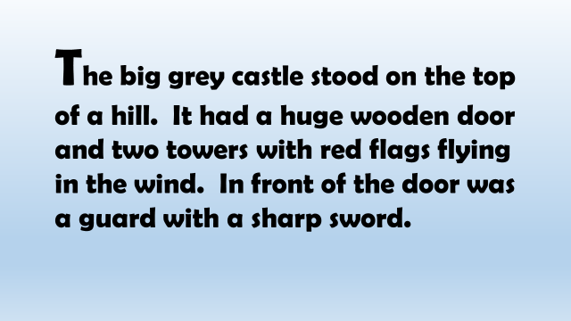

What to include

