PSHE
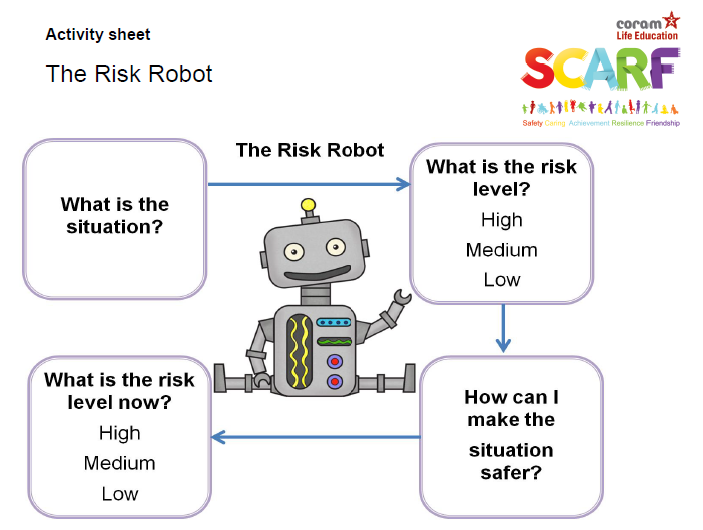
Use the risk robot for the situations below:
- Crossing a busy road
- Drinking from an unlabelled bottle
- Playing near a railway line
- Singing in front of the whole school
- Playing in the school rounders / netball / football team
- Other ideas.
For each situation ask children why they have rated high, medium or low. For example, a child may say that playing near a railway line is low risk as they could mean playing in a garden near a railway line but with a high fence between the two – or a disused railway line.

Example:
- What is the situation? Crossing a busy road
- What is the risk level? May be high because of the chance of being hit by a vehicle. Traffic may be moving too fast to cross safely.
- How can I make the situation safer? Cross at a zebra or pelican crossing; cross with an adult; wait until there are no cars coming; cross at a bridge or a subway.
- What is the risk level now? Depending on what action the children having chosen they may now rate this as medium or low risk.

