Topic planning Debden C. of E. Primary Academy
Year: 2018 Term : Spring Class: Minnows Year: 1 and 2
Maths |  | English |  | Science |  | Technology
Time  Place Value  Graphs  Money  Multiplication, Division and Fractions  Length and Height  Consolidation |  | Reading. Daily Phonics.  Spelling of tricky words and High Frequency words  Shared reading  Individual reading  Writing  Talk 4 Writing;  Poetry;  Losing and Finding stories  Warning Stories;  Information texts  Recounts  Weekly GPS activities  Speaking & Listening:  Role Play  Story telling  Circle Time |  | Living Things & Habitats  STEM activity for Dads-Fri Spring 2 |  | Design Technology:  Designing and making our own boats  Models (Islands),  Computing:  Walking with Dinosaurs (CS)  Code-tastic (CS)
Other |  |  | R.E.
Circle time  Personal, Social, Health, Education (weekly)  Feelings and Relationships  Right and Wrong |  | We are Explorers  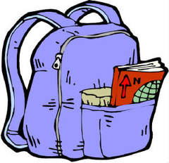 |  |  |  |  | Special times:  Special Words and Stories
History |  | Geography |  | Music |  | Art |  |  | P.E.
Explorers,  Boats and Ships  Charles Darwin |  | UK, Seas, Oceans & Continents of the World  Great Barrier Reef  Making and Reading Maps  Compass Points  Galapagos Islands |  | In The Groove  I Wanna Play in A Band |  | J.M.W. Turner (Watercolours and Collages)  Sculptures,  Sketching |  |  | Gymnastics  Swimming  Games-  Ball skills, Football/ Hockey  Dance-KS1 Festival

